**Order your Woodville Warriors school shirt today**

NEW DESIGN 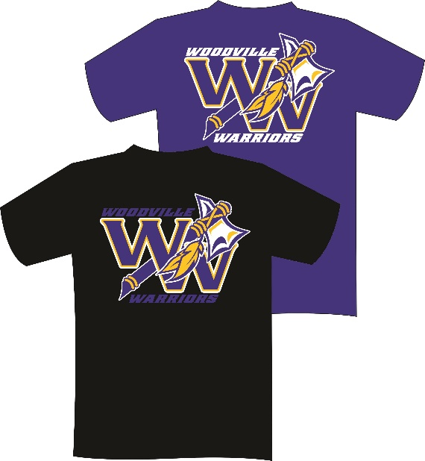

ww

The

DOUBLE DUB

PRINT ON FRONT AND BACK

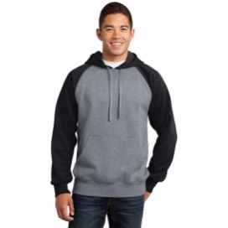 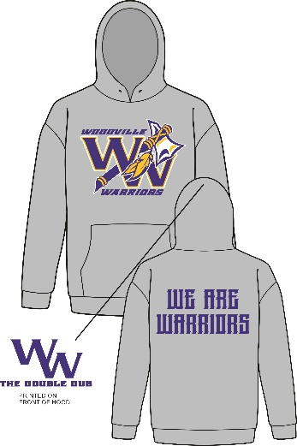 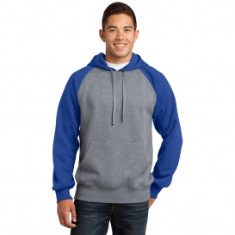

*Two hoody color* options

Full-zip jacket now available. 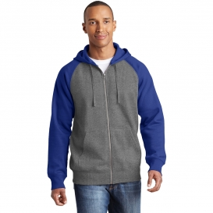

Orders DUE by Friday Oct . 5