Parent/Teacher Conferences

Dear Parents,

Parent Teacher Conferences will be scheduled Tuesday, March 5th from 1:00 p.m. - 7:00 p.m., and Thursday, March 7th from 1:00 p.m. - 2:50 p.m. We urge you to make every effort to attend Parent Conference.

Sincerely,
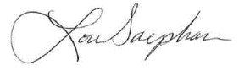
Lou Saephan
Principal/Superintendent

Note: We will be on minimum day schedule and all K-8 students will be dismissed at 12:50 p.m.

Conferencias de padres/maestros

Estimados padres,

Conferencias de padres y maestros se programará el martes, 5 de marzo de 1:00 p.m. - 7:00 p.m. y jueves, 7 de marzo de 1:00 p.m. - 2:50 p.m. Por favor de hacer todo lo posible para asistir a las conferencias.

Atentamente,
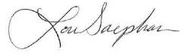
Lou Saephan
Director

Nota: Estaremos en horario mínimo y todos los estudiantes K-8 saldrán a las 12:50 p.m.

