Get your School Shirt and Hoody
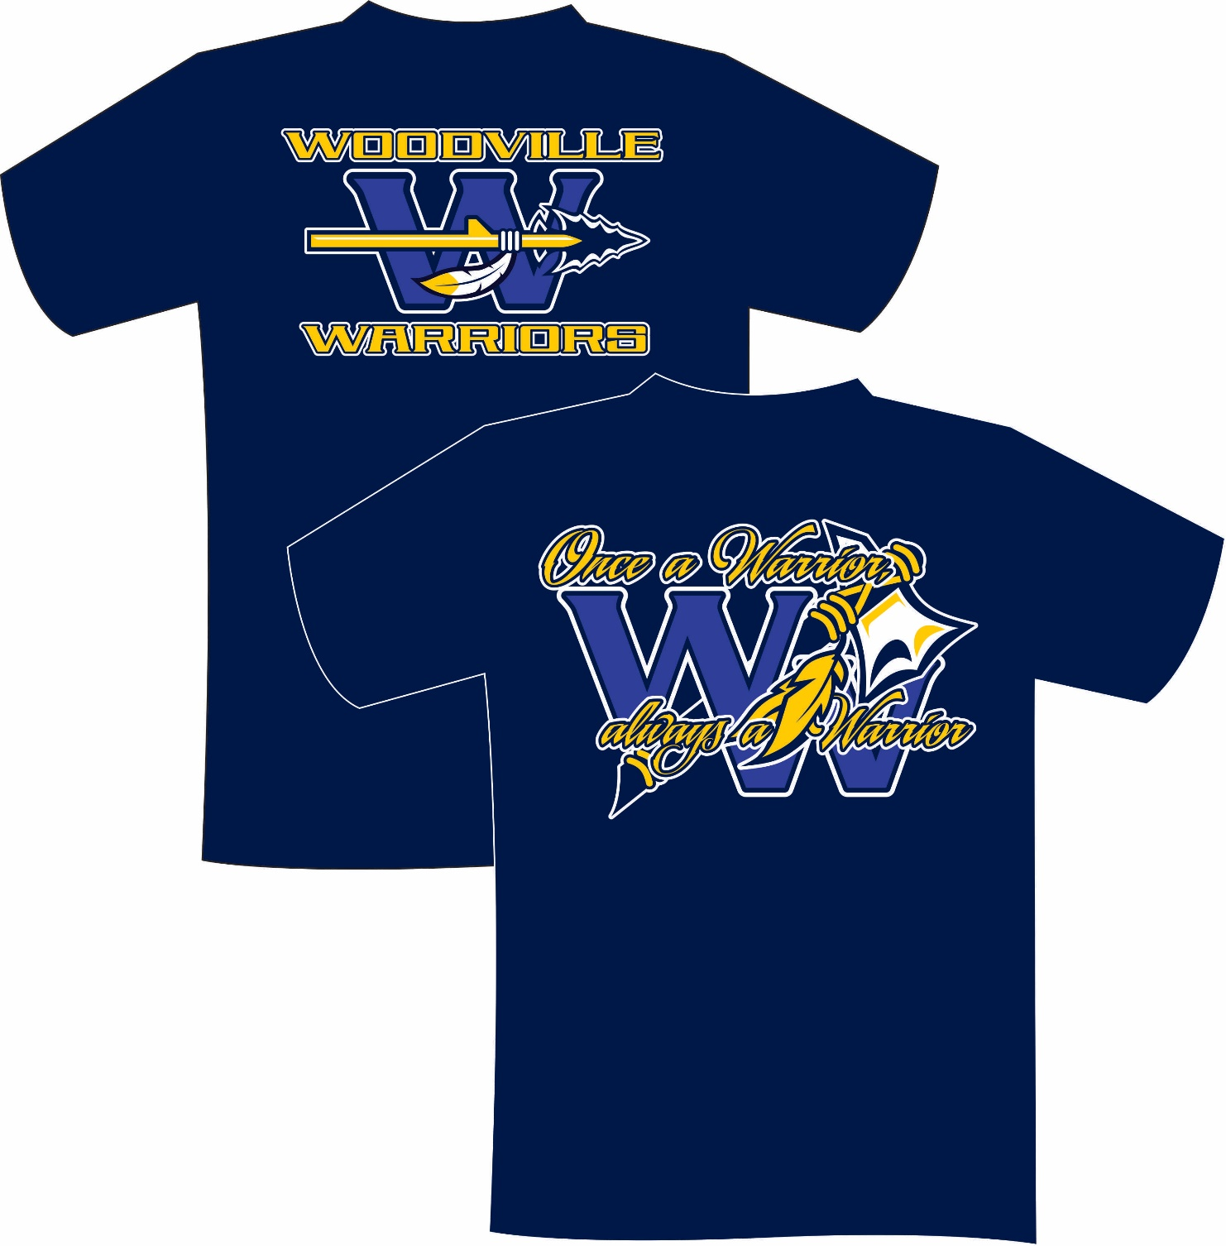
TODAY
Orders due by Nov. 5, 2019

