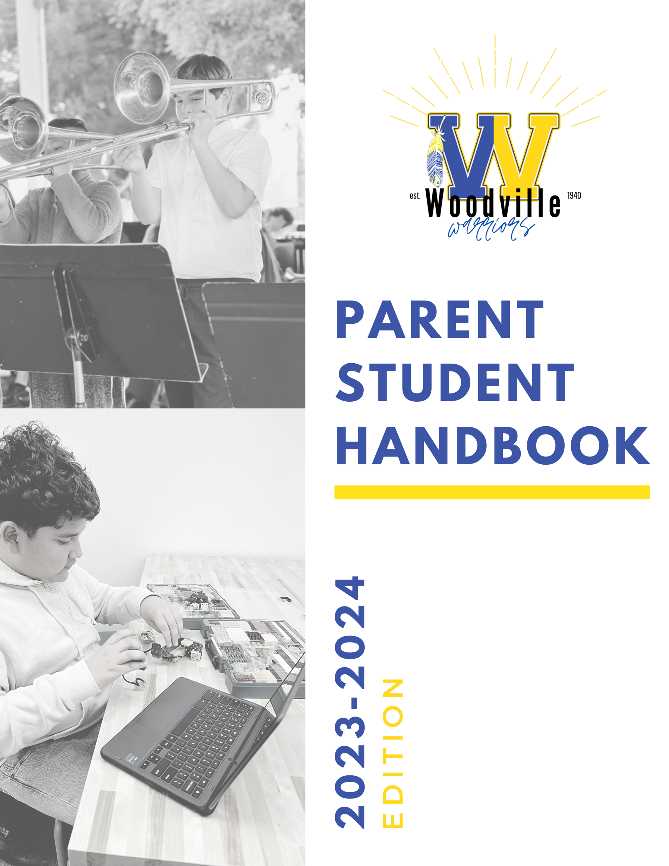

District & Administrative Staff

District and Administrative Staff
Superintendent | Lou Saephan | lsaephan@woodville.k12.ca.us
Principal | Amanda K. Renteria | arenteria@woodville.k12.ca.us
Business Manager | Maira Salinas | msalinas@woodville.k12.ca.us
District Office Secretary | Carmela Morales | cmorales@woodville.k12.ca.us
Director of Expanded Learning | Othoniel Figueroa | ofigueroa@woodville.k12.ca.us
MOT Director | Oscar Baez | obaez@woodville.k12.ca.us
IT Director | Ruben Castañeda | it@woodville.k12.ca.us
Food Services Manager | Marlene Humphrey | mhumphrey@woodville.k12.ca.us
District and School Secretary | Monica Guereca | mguereca@woodville.k12.ca.us
Attendance and Health Clerk | Theresa Tapia | ttapia@woodville.k12.ca.us

Updated: 8/2/2023

Woodville Union School District Board of Trustees
President | Miguel Guillen | mguillen@woodville.k12.ca.us
Clerk | Amanda Medina | amedina@woodville.k12.ca.us
Trustee | Rick Luna | rluna@woodville.k12.ca.us
Trustee | Diana Oceguera-Martinez | dmartinez@woodville.k12.ca.us
Trustee | Virginia Valencia | vvalencia@woodville.k12.ca.us

Woodville Elementary School Staff

Certificated Staff
Transitional Kindergarten | Connie Estrada-Tsuboi | ctsuboi@woodville.k12.ca.us
Transitional Kindergarten | Maria Hernandez | mhernandez@woodville.k12.ca.us
Kindergarten | Alaina Stansbury | astansbury@woodville.k12.ca.us
Kindergarten | Melissa Sweeden | msweeden@woodville.k12.ca.us
1st Grade | Irene Guillen | iguillen@woodville.k12.ca.us
1st Grade | Selena Maldonado | smaldonado@woodville.k12.ca.us
2nd Grade | Bridget Celata | bcelata@woodville.k12.ca.us
2nd Grade | Sabrina Hinojosa | shinojosa@woodville.k12.ca.us
3rd Grade | Yesenia Martinez | ymartinez@woodville.k12.ca.us
3rd Grade | Irissol Flores | iflores@woodville.k12.ca.us
4th Grade | Shannon Toledo | stoledo@woodville.k12.ca.us
4th Grade | Shawna Young | syoung@woodville.k12.ca.us
5th Grade | Fidela Rodriguez | frodriguez@woodville.k12.ca.us
5th Grade | Dalicia Vasquez | dvasquez@woodville.k12.ca.us
6th Grade ELA and History | Lisa Wilsey | lwilsey@woodville.k12.ca.us
6th Grade Math and Science | Jesus Hernandez | jhernandez@woodville.k12.ca.us
7th Grade ELA and History | Ana Moreno | amoreno@woodville.k12.ca.us
7th Grade Math and Science | Payton Thayer | pthayer@woodville.k12.ca.us
8th Grade ELA and History | Gerardo Herrera | gherrera@woodville.k12.ca.us
8th Grade Math and Science | Roxana Flores | rflores@woodville.k12.ca.us
PE | Matt Ashbrook | mashbrook@woodville.k12.ca.us
Music and Band | Jonathan Rodriguez | jrodriguez@woodville.k12.ca.us
Special Education | Sabrina Serpa | sserpa@woodville.k12.ca.us
Reading Specialist | Jamie Leann Smith | jsmith@woodville.k12.ca.us

Classified Staff
Technician | Daniel Fuentes-Garza | dgarza@woodville.k12.ca.
Food Services | Joan Ramos | jramos@woodville.k12.ca.us
Food Services | Joseph Ruiz | jruiz@woodville.k12.ca.us
Food Services | Maria Gomez | mgomez@woodville.k12.ca.us
Food Services | Maria Redondo | mredondo@woodville.k12.ca.us
Librarian | Yesenia Cervantes | ycervantes@woodville.k12.ca.us
Custodial Staff/Bus Driver | Aurelio Morales | amorales@woodville.k12.ca.us
Custodial Staff | Danny Hernandez | dhernandez@woodville.k12.ca.us
Maintenance/Bus Driver | David Carmona | dcarmona@woodville.k12.ca.us
Instructional Aide | Rosa Esquivel | resquivel@woodville.k12.ca.us
Instructional Aide | Maribel Hernandez | mhernandez2@woodville.k12.ca.us
Instructional Aide | Danielle Medcalf | dmedcalf@woodville.k12.ca.us
Instructional Aide | Nancy Chavarria | nchavarria@woodville.k12.ca.us
Instructional Aide | Nycole Watson | nwatson@woodville.k12.ca.us
Community Liaison | Luis Hernandez | lhernandez@woodville.k12.ca.us
ELL Resource Aide | Brianna Medina | bmedina@woodville.k12.ca.us
RSP Aide | Alyssa Schott | aschott@woodville.k12.ca.us

WUSD Mission Values & Goals

Vision

“Empowering Every Student to Achieve Academic Success Now and in The Future”

Mission

“Woodville Union School District’s Mission is to make persistent progress toward academic excellence. Our learning community strives to meet the educational and social needs of each student, while fostering academic achievement, creativity, independence, and responsibility. The Board, administration, staff, parents, and community are dedicated to empowering students and providing them with the necessary foundation so that they will achieve their full potential and become lifelong learners.”

District Goals for the 2023-2024 school year:
1. Student Learning and Achievement
  - Fully implement the California Common Core State Standards (CCSS) state academic standards
  - Continue to refine EL Master Plan to close achievement gap between EL and EO students
  - Develop and expand College and Career Technical Education (CTE) enrichments
  - Provide learning opportunities at an early age for school readiness
  - Strengthen STEAM (Science, Technology, Engineering, Arts, & Mathematics) instruction at all levels

- Develop a Sense of Connectedness for Students and Staff
  - Ensure safe, secure, healthy, and positive environments promoting school connectedness
  - Expand extra/co-curricular activities such as Fine/Performing Arts, afterschool enrichment programs and/or athletics
  - Implement Positive Behavior Intervention and Supports for the school to reduce incidents that lead to suspension and expulsion
  - Implement Multi-Tiered Support Systems (MTSS) academically and behaviorally
  - Continue to increase ADA% by reducing chronic and irregular student attendance
- Recruit, hire, and retain highly-qualified, talented, and productive staff
  - Relentlessly recruit, hire, and maintain highly qualified staff that reflects the CORE values of the school community
  - Continue to ensure competitive salary and benefits for all staff
  - Improve new employee orientation, increase training, and provide professional development opportunities for all staff
  - Expand opportunities in capacity building for all staff within Woodville USD
- Financial and Fiscal Solvency
  - Effectively manage resources to strengthen our fiscal foundation by developing budgets that are aligned to the Local Control Accountability Plan and Board Goals
  - Effectively manage Federal and State categorical programs to meet applicable audit standards
  - Maintain a position of financial stability with reserve levels exceeding the State minimum for Elementary School Districts and consistent with School Board Policy minimum of 10%
  - Maintain a position of unqualified audit reports and positive interim certification
  - Provide total transparency of the Woodville USD budget with the posting of all budgetary documents on the district website
- Facilities, Projects, and Basic Needs
  - All facilities will be clean, safe, secure, and maintained
  - Develop a Facility Master Plan/priority list of facility improvement projects and maintenance needs
  - Provide total transparency in all services and projects
  - Develop a Woodville USD facility needs assessment/scope of work for the utilization of Modernization dollars in 2020
- Positive Community Relations
  - Actively engage the community to promote shared responsibility for student success
  - Increase participation in parent education, with particular focus on 21st Century Learning, to support student success
  - Continue the use of social media and other technology tools to keep parents, staff, and the community informed
  - Expand community/industry partnerships to provide opportunities for students to develop career readiness skills

2023-2024 School Calendar

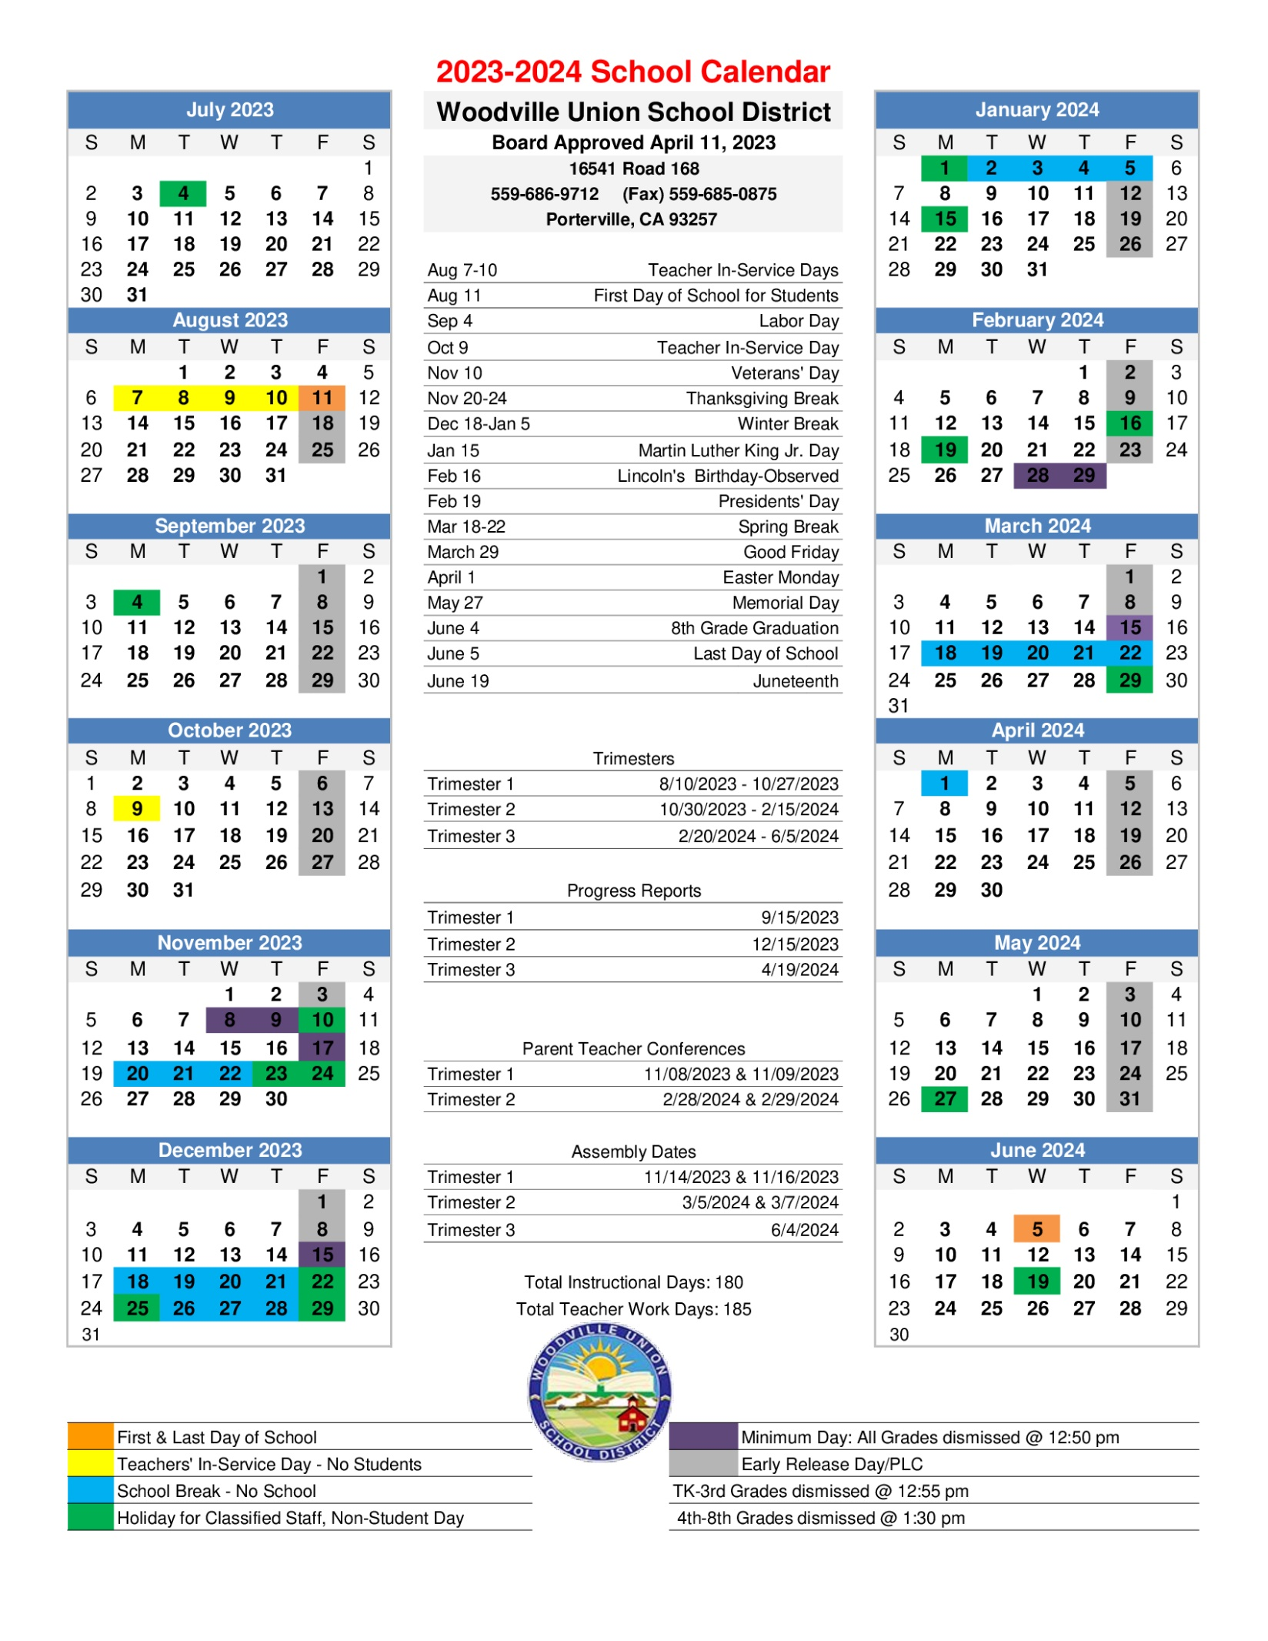

Bell Schedule

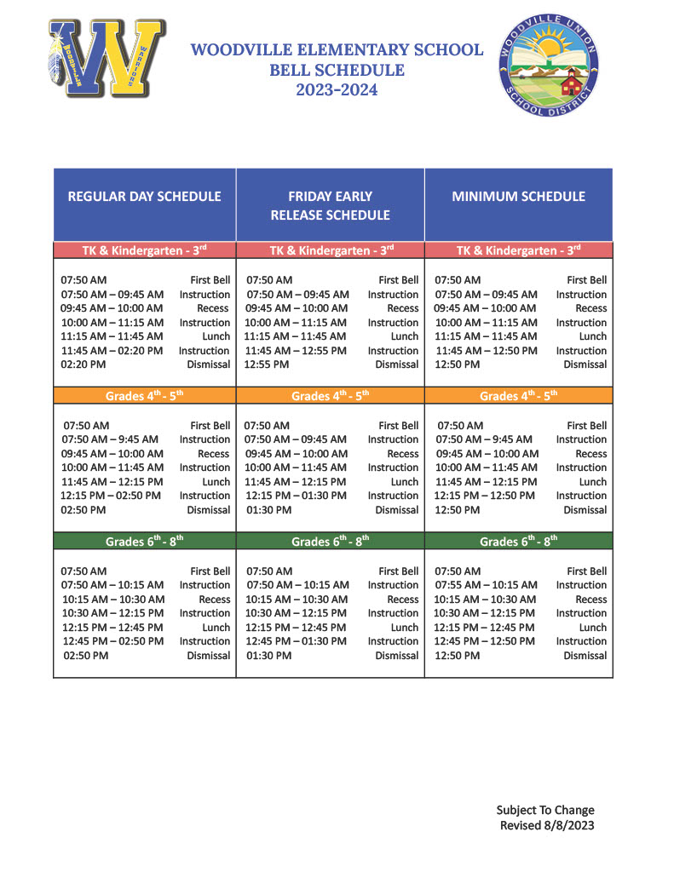

Get Connected
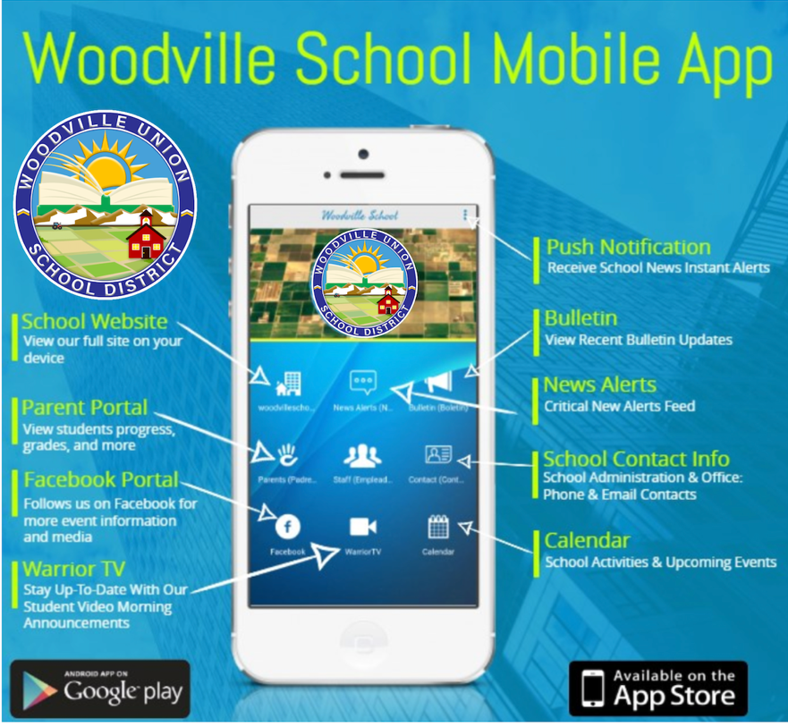

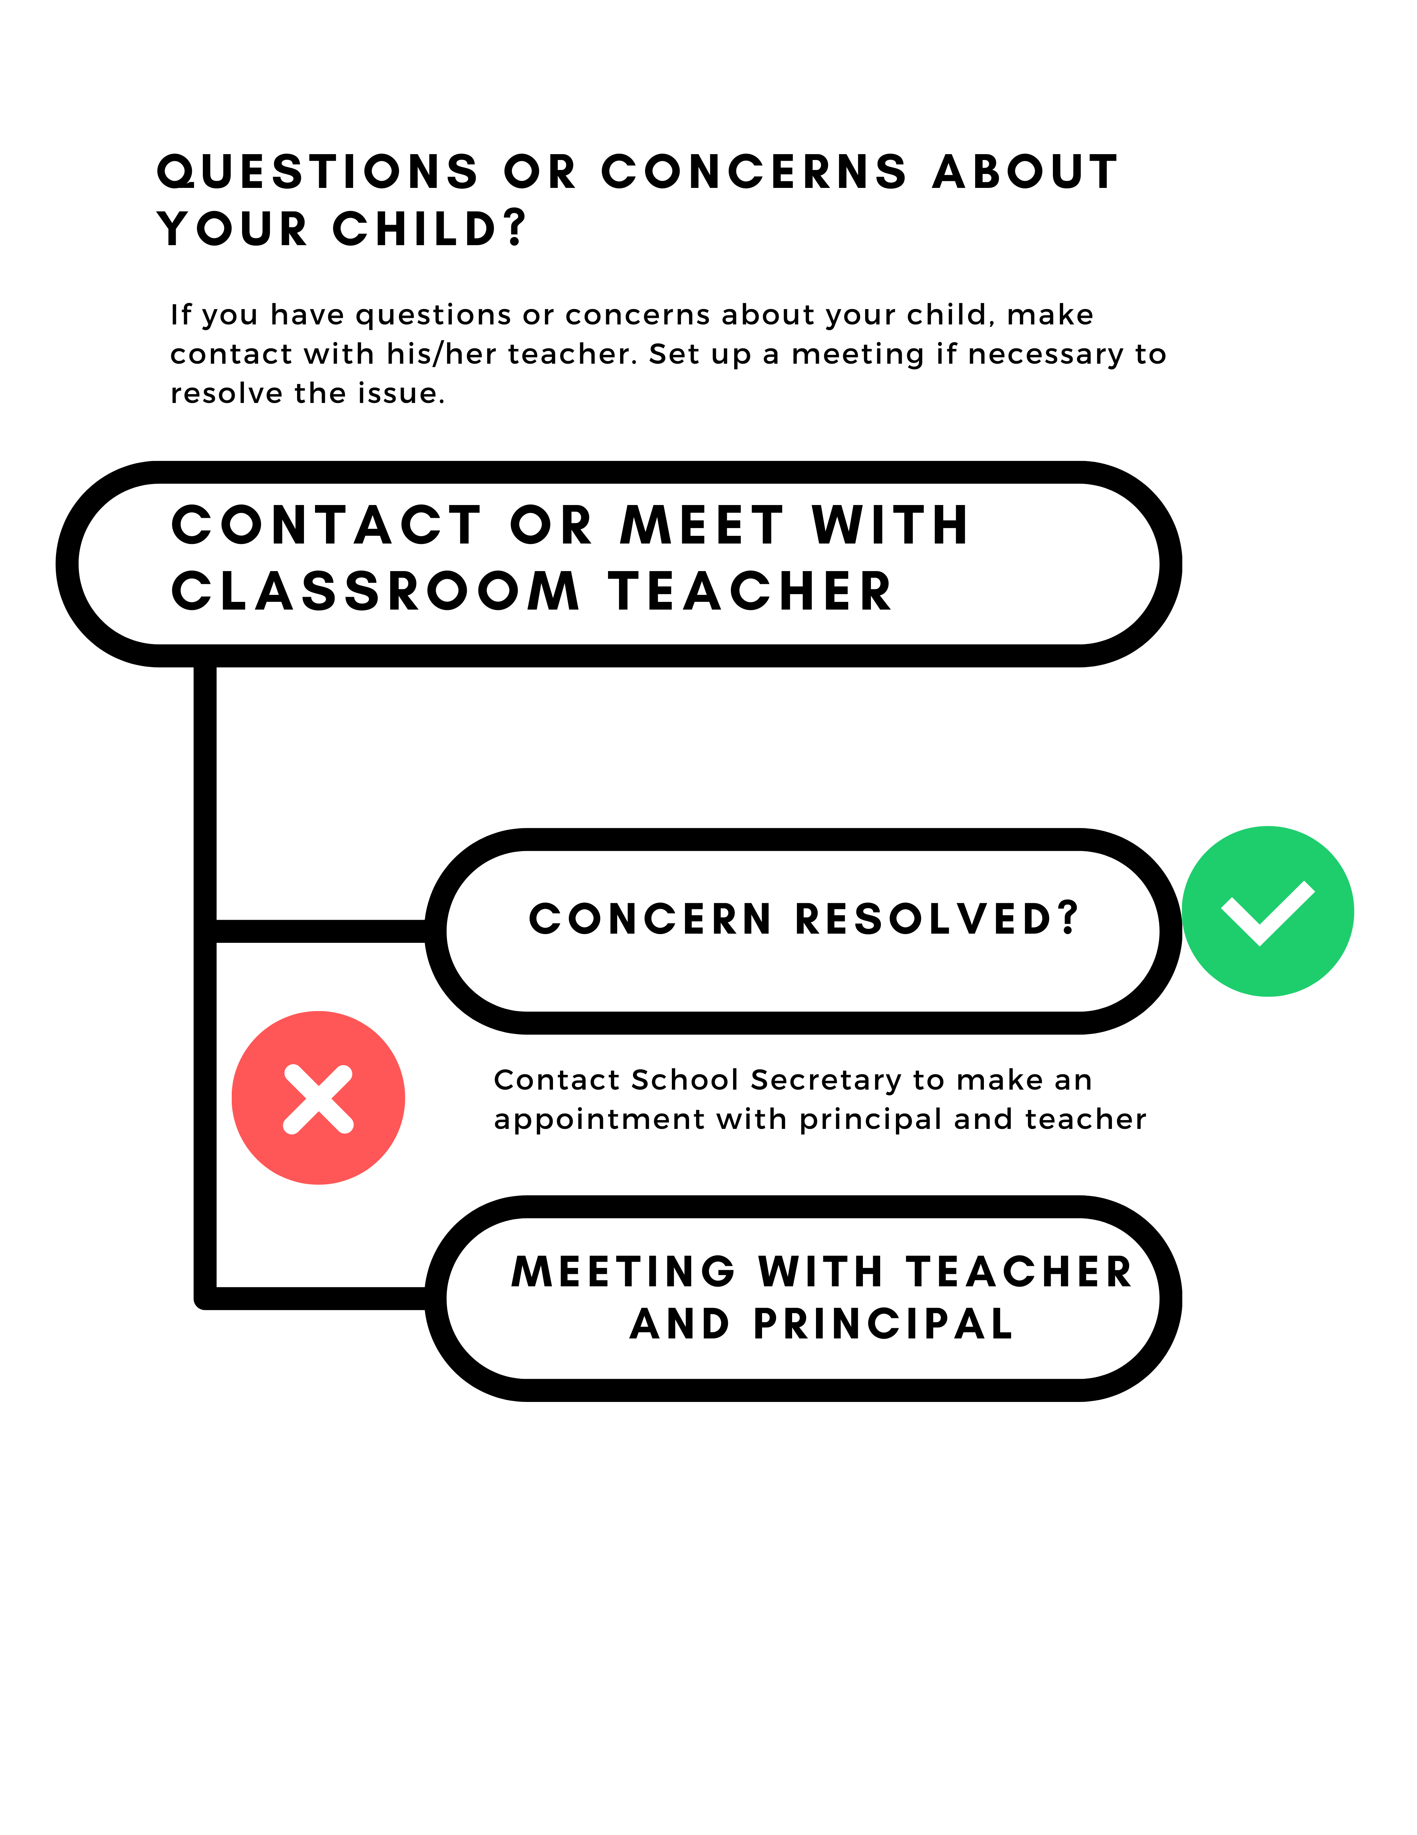

General School Information

FOGGY DAY PROCEDURES
The Woodville Union School District procedures regarding bus transportation when a foggy day schedule is called are as follows:
- If it is determined that it is too foggy for buses to run, a foggy day schedule is declared. To find
out whether a foggy day has been declared, watch Channel 26; Channel 47, check WUSD website, Facebook or Instagram accounts. Woodville Elementary will also make a phone broadcast to notify parents of a foggy day.
The television will indicate one of the following situations:
  - PLAN A: All buses on a 2-hour delay. Bus will leave Woodville Elementary at 9:00 a.m. to pick up students.
  - PLAN B: All buses on a 3-hour delay. Bus will leave Woodville Elementary at 10:00 a.m. to pick up students
  - PLAN C: All buses are canceled (conditions unsafe for bus travel).
- During a foggy day schedule, all classes will begin at 9:30am. A modified schedule will be followed for the entire day. If a parent determines it is unsafe for a student to walk or ride a bike to school, the parent must write a note to excuse the students tardy. Please include the date and time of departure from your home. An absence for an entire day due to fog will be unexcused. It is the student's responsibility to make up any work missed due to fog.

INDEPENDENT STUDY
The Woodville Union School District considers independent study as an optional alternative instructional program for emergency purposes only.
The Principal or designee shall ensure that a written Independent Study agreement, as prescribed by law, exists for each participating student. A copy of this agreement shall be maintained on file. Independent Study may be used to provide expanded opportunities for study, research, and/or application of knowledge. The minimum duration of the short-term Independent Study contract must be for a minimum of five consecutive days with a maximum of 10 consecutive days per school year only. Parents must notify the office at least 2 weeks in advance to request a short-term independent study contract.

NOTE: Students that go on Independent Study do not qualify for the Perfect Attendance Award.

TRANSITIONAL KINDERGARTEN AND KINDERGARTEN PRE-REGISTRATION
Pre-registration for Kindergarten begins each year in the Spring. Parents are required to bring the following materials and information with them at the time they register:
- Legal evidence of birth such as a birth certificate
- Up to date immunization record which includes: Polio, DPT, MMR (measles, mumps, and rubella), Hepatitis B, Varicella and TB Skin Test showing results
- Proof of address
- Copy of Social Security card (optional)
- Copy of child’s last physical exam
- A child must be five years old on or before September 1st of the current school year.

TRANSITIONAL KINDERGARTEN
The Woodville Union School District transitional kindergarten program shall admit children whose fifth birthday lies between: (Education Code 48000).
(1) November 2 and December 2 in the 2012-13 school year
(2) October 2 and December 2 in the 2013-14 school year
(3) September 2 and December 2 in the 2014-15 school year and each school year thereafter
Parents/guardians of eligible children shall be notified of the availability of this program and the age, residency, and any other enrollment requirements. Enrollment in the transitional kindergarten program shall be voluntary.

SCHOOL ADMISSION
The Board of Trustees encourages the enrollment and appropriate placement of all school-aged children in school. The Superintendent or designee shall inform parents/guardians of students entering the school district at any grade level about admission requirements and shall assist them with enrollment procedures.

The Superintendent or designee shall verify the student's age, residency, and any other admission criteria specified in law and in Board policies and administrative regulations.

CRITERIA FOR RESIDENCY
A student shall be deemed to have complied with district residency requirements for enrollment in a district school if he/she meets any of the following criteria:
- The student's parent/guardian resides within district boundaries (Education Code 48200).
- (2) The student is placed within district boundaries in a regularly established licensed children's institution a licensed foster home, or a family home pursuant to a court-ordered commitment or placement (Education Code 48204).
- The student has been admitted through an inter-district attendance option (Education Code 48204, 48356).
- The student is an emancipated minor residing within district boundaries (Education Code 48204).
- The student lives with a caregiving adult within district boundaries (Education Code 48204).
- The student resides in a state hospital located within district boundaries (Education Code 48204).
- The student is confined to a hospital or other residential health facility within district boundaries for treatment of a temporary disability (Education Code 48207).

INTER-DISTRICT ATTENDANCE
The Board of Trustees recognizes that parents/guardians of students who reside in one district may, for a variety of reasons, choose to enroll their child in a school in another district. An inter-district attendance permit may be issued upon approval of both the district of residence and the district of proposed attendance. The Superintendent or designee may approve an inter-district attendance permit for a student for any of the following reasons:

- When the student has been determined by staff of either the district of residence or district of proposed attendance to be a victim of an act of bullying as defined in Education Code 48900(r). Such a student shall be given priority for inter-district attendance under any existing inter-district attendance agreement or, in the absence of an agreement, shall be given consideration for the creation of a new permit. (Education Code 46600).
- To meet the childcare needs of the student. Such a student may be allowed to continue to attend district schools only as long as he/she continues to use a childcare provider within district boundaries.
- To meet the student's special mental or physical health needs as certified by a physician, school psychologist, or other appropriate school personnel.
- When the student has a sibling attending school in the receiving district, to avoid splitting the family's attendance.
- To allow the student to complete a school year when his/her parents/guardians have moved out of the district during that year.
- To allow the student to remain with a class graduating that year from an elementary, or middle school.
- When the parent/guardian provides written evidence that the family will be moving into the district in the immediate future and would like the student to start the year in the district.
- When the student will be living out of the district for one year or less.
- When recommended by the school attendance review board or by county child welfare, probation, or social service agency staff in documented cases of serious home or community problems which make it inadvisable for the student to attend the school of residence.
- When there is valid interest in a particular educational program not offered in the district of residence.
- To provide a change in school environment for reasons of personal and social adjustment.
- Aside from the inter-district form, parents or guardian must sign a contract agreeing to follow all Woodville USD policies and procedures.

The Superintendent or designee may deny initial requests for inter-district attendance permits due to limited district resources, overcrowding of school facilities at the relevant grade level, or other considerations that are not arbitrary. However, once a student is admitted, the district may not deny him/her continued attendance because of overcrowded facilities at the relevant grade level.

Within 30 days of a request for an inter-district permit, the Superintendent or designee shall notify the parents/guardians of a student who is denied inter-district attendance regarding the process for appeal to the County Board of Education as specified in Education Code 46601.

Pending a decision by the two districts or an appeal by the County Board, the Superintendent or designee may provisionally admit a student who resides in another district for a period not to exceed two school months (Education Code 46603).

Students who are under consideration for expulsion or who have been expelled may not appeal inter-district attendance denials or decisions while expulsion proceedings are pending or during the term of the expulsion (Education Code 46601).

STUDENT ARRIVAL AND DROP-OFF/PICK-UP
Students shall be under the supervision of the school authorities from the time they leave home in the morning until they return to their homes in the afternoon. Students shall be under the school's supervision at all school-sponsored functions such as athletic contests, class parties, field trips, school dances, etc. Students are asked to arrive at Woodville Elementary School no earlier than 7:30 A.M, unless the students are attending a before school program. Once students have entered the school grounds, they may NOT leave campus for any reason during the school day.

After school, students are to go directly home, ride the bus, or be picked-up unless participating in an appropriate after-school activity. Students waiting to be picked up by parents should wait at the designated pick-up areas. Students are not permitted to ride their bike on school grounds.

The Tulare County Sheriff Department monitors traffic around the Woodville Elementary School campus for student and staff safety. Traffic citations may be issued for the unauthorized or unsafe drop-off of students. It is recommended that parents turn their vehicle into a parking space when dropping-off or picking-up a student.

RELEASE OF STUDENTS DURING SCHOOL DAY
Students will not be permitted to leave school with any person who is not their parent, guardian or emergency contact person (previously authorized in writing by the parent or guardian). Individuals picking up students may be required to show valid identification. Students leaving campus must sign out at the Attendance Office as they depart.

BICYCLES, SCOOTERS, AND SKATEBOARDS
Students are welcome to ride their bicycles, scooters, and skateboards to and from school. For safety reasons, however, bicycles, scooters, and skateboards may not to be ridden on school grounds, on school sidewalks, in and around parking lots, in or by the bus area. Law requires appropriate helmets be worn.

The school will not assume responsibility for lost, stolen or damaged bicycles, scooters, and skateboards. However, to assist students with their security, the school provides an enclosed area for bicycle, scooter, and skateboard storage. Students are encouraged to bring locks to school so their bicycles, scooters, and skateboards can be locked up in the fenced area. Students failing to comply with our bicycle, scooter, and skateboard rules may lose their privilege to bring their bicycle, scooter, or skateboard on campus. Motorized biked scooters are not allowed on the school campus, as per police department guidelines.

BUS RIDING STANDARDS
Drivers have full responsibility and authority over students on their bus. The law requires that he/she keep order on the bus for the students’ own safety and protection. Any student may be refused transportation for failure to cooperate in complying with the transportation code.
GENERAL RULES OF CONDUCT ON A BUS
- Students may talk as long as it does NOT become loud or boisterous.
- Students must remain seated while on the bus.
- Students are NOT allowed to throw things in the bus or out bus windows.
- Students should sit properly in their seats facing the front.
- Students are NOT to reach out or lean out of windows. The decision of the driver is FINAL if there is a question about the window placements.
- Students are not to swing, crowd or shove in seats while the bus turns.
- Each student is responsible for their personal property.
- Students that are not regular bus riders will need permission from parent and administration.
- Food, chewing gum or drinks are NOT Allowed on the bus.
- Students who regularly use the bus should get on and get off at the same place and use the same bus unless you have been given permission for a change.
- Students cannot use phones in the bus. Driver may give permission to call.

SCHOOL BUS DISCIPLINARY PROCEDURES
Students violating the above could lose their bus privilege. Bus violators will be warned by the driver. If the warning is NOT heeded, the driver will put student on report to the principal. A student may be temporarily suspended from riding the bus, and parents will be notified. A student who continues to violate bus conduct may be suspended from riding the bus for an indefinite period of time.

VISITORS ON CAMPUS
Parents and guardians are welcome to visit the Woodville Elementary School campus. To ensure minimum interruption to our instructional program, visits to the campus during school hours should be pre-arranged with the teacher and/or Administrator at least 24 hours in advance. Teachers are available to meet with parents during non-instructional times only. Siblings and/or friends of students are not permitted on campus beyond the office. We ask that you adhere to the following procedures:

- Schedule your visit in advance with your child’s teacher.
- Check in at the school office BEFORE going to a classroom. You will be given a visitor’s pass.
- Take a seat at the back of the classroom where you can observe your child.
- If you have any questions, write them down and talk to the teacher if she/he has some free time after school.
- Visitors without a pass will be asked to return to the office to check in.

Students from high schools or high school age visitors are not permitted on campus while classes are in session without administration permission. High school students will not be permitted to attend Woodville Elementary school functions or activities during regular school hours without prior approval by administration. Approved high school students attending Woodville Elementary functions or activities must be accompanied by his/her parent(s) or legal guardian. All approved high school students must report to the school office and sign-in prior to attending any Woodville Elementary functions or activities during regular school hours. Non-school personnel must report to the school office between the hours of 7:00 am and 4:00 pm. Approved campus visitors will be signed in and presented with visitor identification before being released into classroom or yard areas (Penal Code 627 and 32210).

All visitors are required to enter the school grounds through the main office and must identify themselves to office personnel. Visitors are required to register in the main office before entering any school building or the school grounds when school is in session and must sign out in the main office upon leaving. All information on the visitor sign-in sheet must be completed before any visitor will be issued a Visitor’s Badge. For security and identification purposes, a Visitor’s Badge must be worn at all times and must be returned in the main office as the visitor leaves.

Unless authorized by the Superintendent, or designee no agents/salesmen shall be permitted on campus to discuss business propositions of any kind with teachers or students during school hours.

CLOSED CAMPUS DURING INSTRUCTIONAL TIME
Woodville Elementary School maintains a closed campus during instructional hours. All gates to the campus remain locked for security purposes. Students entering the campus during instructional hours must enter through the main office. Visitors to the campus must enter through the main office.

TELEPHONES
Students will not be called to the telephone during the school day. Messages that are important will be delivered to the student with a request to return a call during the next available break. Only in emergencies will students be allowed to use the office phone.

LOST AND FOUND
For the convenience and benefit of the student, a lost and found is maintained in the office. All articles found about the school should be turned in to this location. Owners of lost articles should inquire in the Office and reclaim their missing items. Confiscated clothing will be held for parent pick-up for 10 days, after which it will be forwarded to the Lost and Found. All unclaimed items will be discarded after the last day of school.
Attendance

ABSENCE POLICY
The law states that a student's absence or tardy may only be excused due to: Personal Illness; Quarantine; Medical, dental, chiropractic or optometrist appointment (student appointment only); Attendance at funeral services for a member of the immediate family (One day if the service is in California or three days if the service is out of state); Jury duty; Illness or medical appointment, during school hours, of a child of whom the student is a custodial parent. With prior written request of the parent/guardian, and approval of the principal, an absence shall be excused or justifiable personal reasons including, but not limited to: An appearance in court; Funeral; Observation of a holiday or ceremony of his/her religion; Attendance at religious retreats (not to exceed four hours per trimester); Attending an employment conference or educational conference on the legislative or judicial process offered by a non- profit organization; or to serve as a member of a precinct board for an election (Education Code 48205).

TARDY POLICY
Students are expected to be on time daily. It is in violation of school rules and state law (Education
Code 48200) if a child is tardy without a note or phone call verifying a valid excuse. Tardies are
excused only for the same reasons as legal absences. If tardies become numerous, the school site will
address the problem. If the problem continues, referrals may be made to district attendance officers and eventually, the School Attendance Review Board (SARB).

Students in grades 4-8 will receive serve Saturday after 10 tardies in one month. Saturday School will be held once a month and be supervised by certificated staff.

EXCUSED ABSENCES
- Notwithstanding Section 48200, a pupil shall be excused from school when the absence is:
- Due to his or her illness.
- Due to quarantine under the direction of a county or city health officer.
- For the purpose of having medical, dental, optometric, or chiropractic services rendered.
- For the purpose of attending the funeral services of a member of his or her immediate family, so long as the absence is not more than one day if the service is conducted in California and not more than three days if the service is conducted outside California.
- (e) For the purpose of jury duty in the manner provided for by law.
- (f) Due to the illness or medical appointment during school hours of a child of whom the
- pupil is the custodial parent.
- (g) For justifiable personal reasons, including, but not limited to, an appearance in court,
- attendance at a funeral service, observance of a holiday or ceremony of his or her
- religion, attendance at religious retreats, attendance at an employment conference, or
- attendance at an educational conference on the legislative or judicial process offered by
- a nonprofit organization when the pupil’s absence is requested in writing by the parent
- or guardian and approved by the principal or a designated representative pursuant to
- uniform standards established by the governing board.
- (h) For the purpose of serving as a member of a precinct board for an election pursuant to
- Section 12302 of the Elections Code.
- A pupil absent from school under this section shall be allowed to complete all assignments and tests missed during the absence that can be reasonably provided and, upon satisfactory completion within a reasonable period shall be given full credit therefor. The teacher of any class from which a pupil is absent shall determine which tests and assignments shall be reasonably equivalent to, but not necessarily identical to, the tests and assignments that the pupil missed during the absence.
- For the purposes of this section, attendance at religious retreats shall not exceed four hours per semester.
- Absences pursuant to this section are deemed to be absences in computing average daily attendance and shall not generate state apportionment payments.
- “Immediate family,” as used in this section, has the same meaning as that set forth in Education Code 45194, except that references therein to “employee” shall be deemed to be references to “pupil.”
A pupil may not have their grade reduced or lose academic credit for any absences excused pursuant to this section when missed assignments and tests that can reasonably be provided are satisfactorily completed within a reasonable period of time.

ASSIGNMENTS MISSED DURING AN EXCUSED ABSENCE
A student with an excused absence will be allowed to complete all assignments and tests missed during the absence that can be reasonably provided and, upon satisfactory completion within a reasonable period of time, will be given full credit. The student's teacher will determine the tests and assignments that will be equal to, but not necessarily the same as, the tests and assignments that the student missed during the absence (Education Code 48980).

ABSENCE FOR RELIGIOUS PURPOSES
With prior written consent of parent/guardian and approval of the principal, a student may be excused in order to participate in religious exercises or to receive moral and religious instruction at a place away from school property. The student must attend school at least the minimum school day and shall be excused from school for such purpose on no more than four days per school month (Education Code 46014).

TEMPORARY DISABILITY
A pupil with a temporary disability that makes attendance in the regular day classes or alternative education program in which the pupil is enrolled impossible or inadvisable shall receive individual instruction provided by the district in which the pupil is deemed to reside (Education Codes 48206.3, 48207, 48208).

HOSPITALIZED STUDENTS
It shall be the primary responsibility of the parent to notify the school district in which the student is temporarily residing of his presence in a qualifying hospital. Within five working days of the notification, the school district shall determine eligibility and shall, if eligible, place the student within an additional five days in an instructional program (Education Code 48207).

SCHOOL ATTENDANCE REVIEW BOARD (SARB)
This board is staffed by community agency persons and volunteers to deal with students and families prior to being referred to the District Attorney or County Probation. The students are referred after all school resources and services resources have been exhausted (Education Code 48263, 48320-4).

SARB LETTERS
Letter 1) 3 unexcused absences 6 parent/guardian excused absences (without a doctor’s note), a SARB Warning Letter will be sent home.
Letter 2) 5 unexcused absences, a SARB Meeting Letter will be sent out. A face-to-face meeting with the administration is necessary.
Letter 3) 7 unexcused absences, a final SARB Letter will be sent out followed by a referral to the SARB Panel.

SARB will ask the parent and the student to sign an attendance contract. Failure to comply with the contract will result in the order of a citation to appear in court.
1st Conviction: A fine of not more than $100.00 plus penalties up to $375.00.
2nd Conviction: A fine of not more than $320.00 plus penalties up to $750.00.
3rd or Subsequent Conviction: A fine of not more than $500.00 plus penalties up to $1,000.00. 13202.7 V.C.: Any minor under the age of 18 years old who is habitual truant may have his/her driving privilege suspended for one year.

SARB will report truancy cases to Child Welfare Services, CalWorks, Social Security and Tulare County Social Services. A truant child may result in a reduction or elimination of individual or family benefits from these agencies.

TRUANCY
Any pupil subject to compulsory full-time education or to compulsory continuation education who is absent from school without valid excuse three full days in one school year or tardy or absent for more than any 30-minute period during the school day without a valid excuse on three occasions in one school year, or any combination thereof, is a truant and shall be reported to the attendance supervisor or to the superintendent of the school district (Education Code 48260 (a).
If the problem continues, the student will be referred to the School Attendance Review Board (SARB). School attendance is mandatory. It is the parent's responsibility to ensure his/her student attends school regularly.
Unexcused absences will be made up during Saturday School for students in grades 4-8.

NOTIFICATION OF TRUANCY
Upon a pupil's initial classification as a truant, the school district shall notify the pupil's parent or guardian, by first-class mail or other reasonable means, of the following:
- That the pupil is truant.
- That the parent or guardian is obligated to compel attendance of the pupil at school.
- That parents or guardians who fail to meet this obligation may be guilty of an infraction and subject to prosecution pursuant to Article 6 (Education Code 48290) of Chapter 2 of Part 27.
- That the parent or guardian has the right to meet with appropriate school personnel to discuss solutions to the pupil's truancy.
- That the pupil may be subject to prosecution under Education Code 48264.
- That the pupil may be subject to suspension, restriction, or delay of the pupil's driving privilege pursuant to Section 13202.7 of the Vehicle Code.
- That it is recommended that the parent or guardian accompany the pupil to school and attend classes with the pupil for one day (Education Code 48260.5).

CHRONIC TRUANCY
Any pupil subject to compulsory full-time education or to compulsory continuation education who is absent from school without a valid excuse for 10 percent or more of the schooldays in one school year, from the date of enrollment to the current date, is deemed a chronic truant, provided that the appropriate school district officer or employee has complied with Sections 48260, 48260.5, 48261, 48262,48263,48291 of the Education Code.
If a chronically truant student is at least age 6 years and is in any of grades K-8, the attendance supervisor shall notify the parents/guardians that failure to reasonably supervise and encourage the student's school attendance may result in the parent/guardian being found guilty of a misdemeanor pursuant to Penal Code 270.1.

The Board of Trustees may deny enrollment to an individual who has been expelled from another school district for acts specified under "II. Expulsion," for the remainder of the expulsion period after a hearing has been held and a determination made that the individual poses a potential danger to either the school district's pupils or employees (Ed. Code Section 48915.1).

Academics

ACADEMICS
Woodville Elementary School is on a Trimester Grading System. Each trimester is approximately 12 weeks long. Official grades will be given four times each year at the end of each trimester. Grades are based on achievement, assessment results, completion and quality of work and progress in the subject area. In addition, parents will receive a progress report at six-week intervals during each trimester. See the academic calendar for the dates of progress and grade reports will be mailed.

METHODS OF GRADING
Standard Based report cards are used in grades TK-5th grade. Students earn a rubric score of 4, 3, 2, and 1 to determine their progress towards proficiency of the standards.
4 = Standard Exceeded
3 = Standard Met
2 = Standard Nearly Met
1 = Standard Not Met

Traditional report cards are used in grades 6th-8th grade. Students earn A, B, C, D, F
A = Excellent P = Passing
B = Above Average I = Incomplete
C = Average NM = No Mark
D = Below Average
F = Failing

Honor Roll will be awarded to students in grades 6th-8th only.
Pricipal’s Award – GPA 3.5 -4.0+
Honor Roll – GPA 3.0 – 3.49

VALEDICTORIAN/SALUDATORIAN DETERMINATION
The Valedictorian(s) will be the student(s) with the highest GPA at the end of the eighth grade year. The Salutatorian(s) will be the next highest GPA not to qualify as a Valedictorian. Final determination will be dependent on good overall citizenship. Valedictorian(s) and Salutatorian(s) may be asked to deliver a speech at graduation or open tryouts may be held for graduation speakers. All graduation speeches must be pre-approved by the Superintendent or designee.

PROGRESS REPORTS AND REPORT CARDS
Progress Reports are issued to all student’s half-way through each trimester. The purpose of progress reports is to inform students and parents of the students’ academic progress and class status. Progress Report grades figure into the calculation of the Report Card or final trimester course grade. Teachers may initiate a progress report at any time necessary to keep students and parents adequately informed on classroom progress. Report Cards (final grades) are issued to all students at the conclusion of the trimester. Report Card grades are recorded on the student’s transcript and become permanent grades.

STUDENT GRADE ACCESS
Parents and/or students may access the online student grading system through the Aeries parent portal which is available on the school website. On the Aeries parent portal, parents and students can access the most current information on progress in each class and attendance. Links to every teacher’s email are also available on this web site. Your student will be given account information by their teacher.

Aeries Gradebook Parental Access System
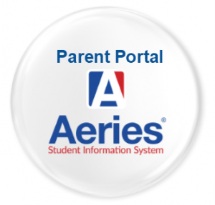
The Aeries Gradebook Parental Access System is a web site that will allow parents and students to access basic student information. The purpose is to improve communication between home and school and increase opportunities for improved student performance.

Setting up an Account
If you have previously attended an informational session about Aeries or provided your email address to our staff, you may have already received a confirmation email from our system.

You can get an account set up to access your student information by:
Emailing the school at it@woodville.k12.ca.us with your name, your student’s name, and your home or cell number that we have in the system at the school. This will validate your email address. You will receive an email from it@woodville.k12.ca.us when your account has been activated (usually within 48 hours). It will include a temporary password, which you can change once you have logged in. All email sent from the school server will come from this email account.

*IMPORTANT: To ensure messages from the school do not get sent to spam/bulk folders, you may need to add this email account to your contacts/favorites/address book list.

Accessing Aeries Access to your student’s attendance, information and grades is available through any web browser. Open your browser (Internet Explorer, Netscape, Firefox, etc.) and in the location or URL box type (Note: Aeries is designed for use with Internet Explorer).

https://woodville.asp.aeries.net/student/LoginParent.aspx?page=default.aspx

The site will not work if you do not type https:// The Aeries Student Information server only accepts connections made over a secure connection. The https:// command tells your browser/computer to only use a secure connection.

Before the login screen is displayed, you may see a Security Alert. This alert is verifying that you want to make a secure connection with our server. Click “Yes” to proceed to the login screen.
Your email address is your user account.

Use the temporary password you received in the Account Activation email to log in. Once you log in, you can change your password.

Information available to users include:
- Student info (General Student information: name, address, phone, etc.)
- Attendance (Shows daily and period attendance for all days of the school year to date)
- Grades (Current Assignments/Grades, Report Card grades, Graduation Status and Transcript (permanent) information).

CITIZENSHIP GRADE
One of the primary aims of the school is directed toward helping students to become good citizens. Valuable teaching and learning time are lost when a student behaves in such a way as to distract from or disrupt instruction. In order to keep parents informed and to recognize good citizenship, a grade is recorded on the report card using:
O = Outstanding
S = Satisfactory
N = Needs Improvement
U = Unsatisfactory

HOMEWORK
The purpose of homework is to reinforce classroom learning and develop a sense of responsibility in students. This can best be done by developing a homework "habit" which establishes homework as a normal expected occurrence. Homework does make a difference in student achievement. Under optimal conditions, students should be expected to spend approximately two hours of home study for every school day if satisfactory results are to be obtained. Homework assignments are expected in all academic subjects.
In assigning homework, teachers will use the following guidelines:
- Homework is assigned on a regular basis and is related to what is being taught in the classroom.
- Usually homework is graded and/or commented on; students will receive credit for completed homework for an excused absence. Departments may have additional homework policies.
- Teachers will attempt to make sure that each student has the skills needed to complete homework before it is assigned.

TEXTBOOKS
To ensure that books are kept in the best possible condition, each student is requested to examine all books issued as soon as possible. Damaged textbooks should be returned to the issuing teacher within 10 days of receipt for replacement or repair. The student will be liable for any damages to a textbook returned after the 10-day period. Never leave textbooks unattended in a classroom or any other crowded location as you will be held responsible if they are lost or stolen.

DEBT OWED LIST
During the trimester, students may incur expenses that result in the student being placed on the “Debt Owed List”. It is the responsibility of each student to pay their bill as soon as possible. A student on the “Debt Owed List” will not be permitted to participate in any extra-curricular activities until the debt is paid. 8th graders may not receive diplomas or be allowed to participate in the graduation ceremonies until all debts are paid. Grades, transcripts, and diplomas may be withheld until all debts have been cleared (Education Code 48904b).

CALIFORNIA STATE ASSESSMENT

PARTICIPATION
Each year students in grades 3-8 and 11 will participate in the California Assessment of Student Performance and Progress (CAASPP) assessment system in accordance with Education Code section 60604. Before testing begins, a parent or guardian may annually submit to the school a written request to excuse his or her child from any or all parts of any CAASPP test for the school year. If a parent or guardian submits an exemption request after testing has begun, any test(s) completed before the request is submitted will be scored and the results reported to the parent or guardian and included in the pupil's records. District employees may discuss the CAASPP assessment system with parents and may inform parents of the availability of exemptions under Education Code section 60615. Employees shall not solicit or encourage any written exemption request on behalf of any child or group of children.

RESULTS OF TESTS
School districts must comply with each of the following requirements:
- Achievement tests are scheduled to be administered to all pupils.
- For assessments that produce valid individual pupil results, the individual results of each pupil tested shall be reported, in writing, to the parent or guardian of the pupil. The report shall include a clear explanation of the purpose of the test, the score of the pupil, and the intended use by the local educational agency of the test score. This subdivision does not require teachers or other local educational agency personnel to prepare individualized explanations of the test score of each pupil. It is the intent of the Legislature that nothing in this section shall preclude a school or school district from meeting the reporting requirement by the use of electronic media formats that secure the confidentiality of the pupil and the pupil's results.
  - For assessments that produce valid individual pupil results, the individual results of each pupil tested also shall be reported to the school and teachers of a pupil. The local educational agency shall include the test results of a pupil in his or her pupil records.
- A pupil or his or her parent or guardian may authorize the release of individual pupil results to a postsecondary educational institution for the purpose of credit, placement, determination of readiness for college-level coursework, or admission.
  - The districtwide, school-level, and grade-level results of the CAASPP shall be reported to the governing board of the school district at a regularly scheduled meeting, and the countywide, school-level, and grade-level results for classes and programs be similarly reported to the county board of education at a regularly scheduled meeting.
  - The state board shall adopt regulations that outline a calendar for delivery and receipt of summative assessment results at the pupil, school, grade, district, county, and state levels.
- Aggregated, disaggregated, or group scores or reports that include the results of the CAASPP assessments shall not be publicly reported to any party other than the school or local educational agency where the pupils were tested.

Positive Behavior System

All pupils shall comply with the regulations, pursue the required course of study, and submit to the authority of the teachers of the school (Education Code 48908).

Woodville Elementary School administration and staff recognizes that students have diverse social, cultural, emotional, and academic needs. Our instructional program is designated to address our students’ academic progress within a safe and secure environment. As a team, we will create a predictable, positive, and safe learning environment for all students by setting high expectations for student behavior and holding them accountable.

Teachers are expected to maintain current communication with parents, expectations, academic accomplishments, challenges and concerns for his/her students. Parents are asked to communicate with their child’s teachers with any concerns they may have and be active participants in their child’s education.

In “Teaching Interrupted” (Public Agenda, 2004), teachers and parents overwhelmingly agree that good student behavior is necessary for schools and students to thrive, an essential condition before teaching and learning can take place.

The strategies are based on research and teacher experience. Time to Teach! promotes both proactive and reactive strategies. Teachers invest time during the first week of the school year teaching students expected behaviors they will need to be successful in order to reap the benefits of increased instructional and learning time.
Dahlgren, R., Malas, B., Faulk, J., & Lattimer, M.(2008). Time to Teach! The Center for Teacher Effectiveness. P. 67-70

Woodville Elementary School is excited to implement TRIBE Behavior System as a practical school-wide and classroom management program that offers strategies for dealing with student discipline problems at the classroom and school-wide level.

TRIBE Behavior System is a school-wide and classroom management program that considers multiple components that make up a safe learning environment such as teachers and staff building positive relationships with students, “Teach-To’s”™ to address classroom rules and routines, Refocus™ as a disciplinary technique that requires 4-6 minutes of student-directed reflection, and classroom arrangement. All students are given a choice to correct their behavior. Their choice will be honored which may result in the progression through the Behavior Management Flow Chart (see visual on next page.)
- Teacher makes verbal prompt/redirection
- Student is time to reflect and complete REFOCUS form
- Morning, lunch, or afternoon detention assigned
- Afterschool detention assigned
- Transition Room
- Administrator Conference with student, teacher, and parent

*A student progressing to two REFOCUS forms per week per teacher or four REFOCUS forms per week school-wide will equate to a lunch detention
**A student progressing to two lunch detentions per week will equate to an after school detention

Good behavior will be encouraged and rewarded in a variety of ways. TRIBE Tokens are handed to students who were “caught” doing something great! Students can collect as many as possible to use at the new student store. Positive postcards are sent home to parents when students’ good behavior should be acknowledged at home. Classrooms with perfect attendance will receive sweet treat rewards.

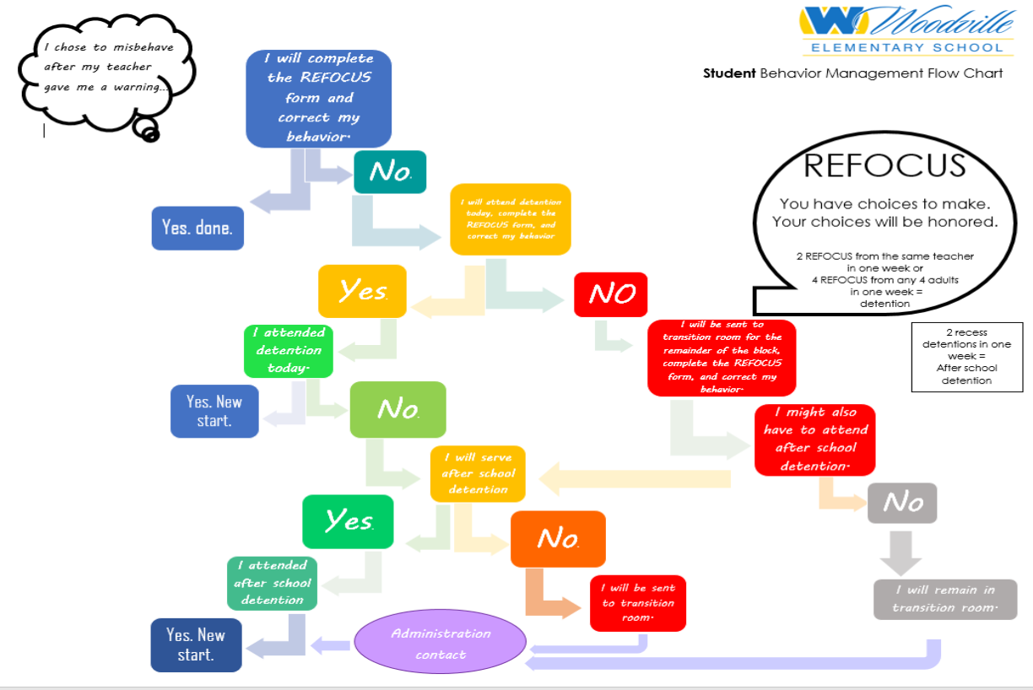

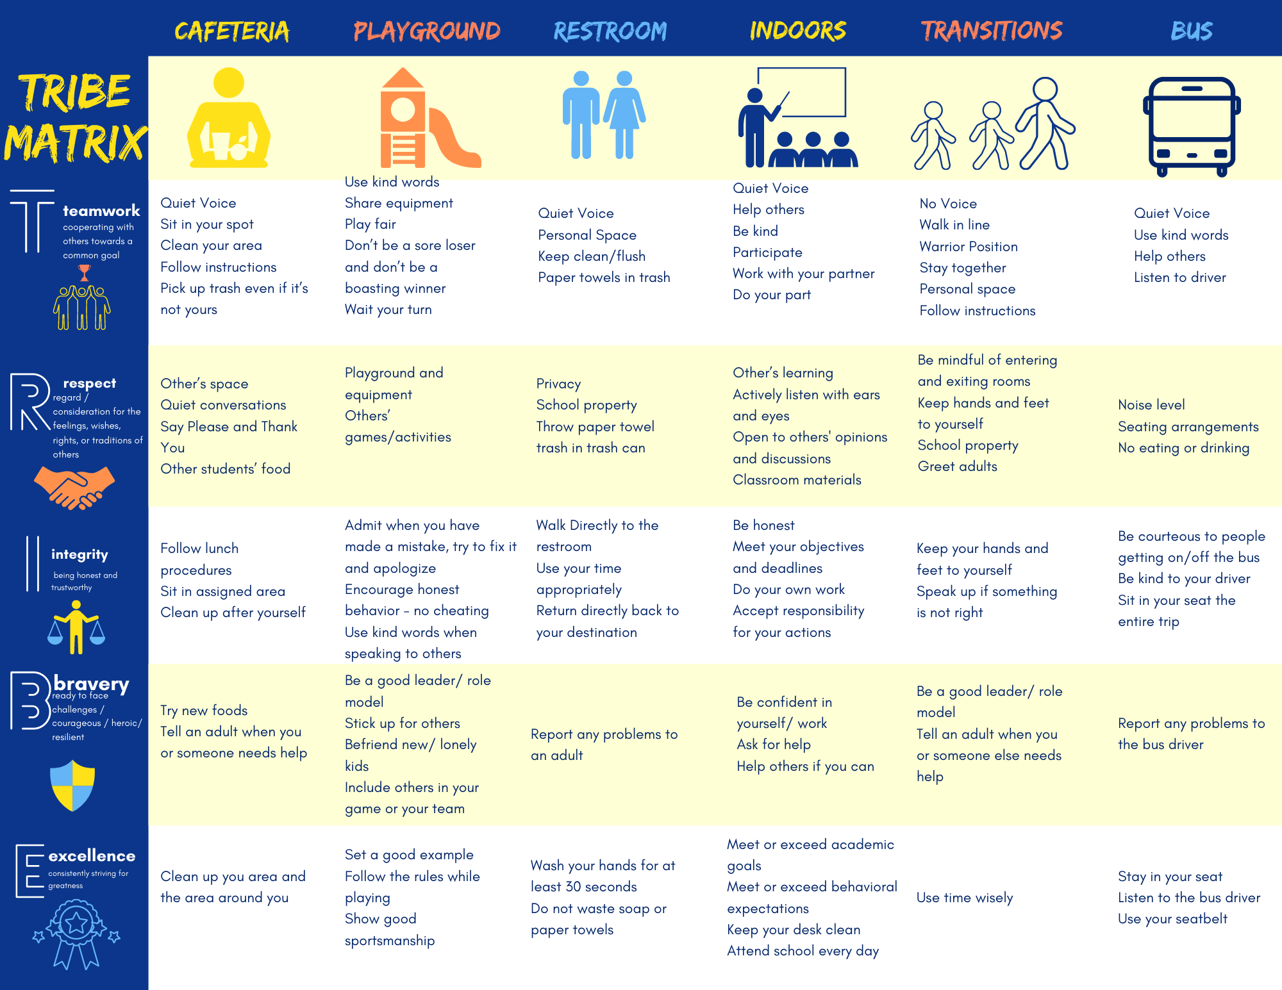
Student Conduct

DISCIPLINE RULES AND REGULATIONS
Rules and regulations are established to maintain an atmosphere conducive to learning. Students who fail to comply with these rules and regulations will be counseled, reprimanded, suspended or expelled and/or arrested as the laws are applied. The Board of Trustees of the Woodville Union School District has
prescribed rules consistent with law or with the rules prescribed by the State Board of Education, for the government and discipline of the schools under its jurisdiction. (E.C. 35291) All pupils shall comply with the regulations, pursue the required course of study, and submit to the authority of the teachers of the schools (E.C. 48921).
Participation/attendance at extracurricular activities is considered a part of the educational program. Participants/ spectators carry responsibilities as representatives of their schools/communities. All rules of student conduct apply also to extracurricular activities. The Board of Trustees may enforce the provisions of Section 35291 by suspending, or, if necessary, expelling a pupil in any elementary school who refuses or neglects to obey any rules prescribed pursuant to that section (E.C. 48906).

ASSERTIVE DISCIPLINE
Woodville Elementary School has adopted its own set of rules for discipline in the classroom and at all other school related activities, in an effort for teachers, pupils, parents and administration to work closer together in bringing about a good school climate for learning.

RESTRICTION
A teacher may restrict for disciplinary purposes the time a pupil under his/her supervision is allowed for recess (E.C.44807.5).

EXCLUSION
The Board of Education may exclude students from attending school for any of the following:
- Filthy or vicious habits, contagious or infectious diseases including noncompliance with state immunizations requirements.
- Physical or mental disability determined to be detrimental to the welfare of other pupils.

OFF CAMPUS CONDUCT
Students also may be subject to discipline, in accordance with law, Board policy, or administrative
regulation, for any off-campus conduct during non-school hours which poses a threat or danger to the safety of students, staff, or district property, or substantially disrupts school activities.

SUSPENSION
Suspension is the temporary removal of a pupil from regular classroom instruction or from school as initiated by a teacher or administrator for adjustment purposes.

Students that administration believes pose a danger to others will be placed on home suspension (Education Code 48911.1).

According to Education Code 48900, students may be suspended and/or expelled from school for having committed
any of the following:
(a) Caused, attempted to cause, or threatened to cause physical injury to another person
(b) Possessed, sold, or otherwise furnished any firearm, knife, explosive, or other dangerous object unless, in the case of possession of any such object, the pupil had obtained written permission from a certificated employee with which the principal or principal's designee concurs.
(c) Unlawfully possessed, used, sold, or otherwise furnished, or been under the influence of any
controlled substance (as defined in the Health and Safety code), alcoholic beverage, or intoxicant of any kind.

- Unlawfully offered or arranged or negotiated to sell any controlled substance and then sold,
delivered, or otherwise furnished to any person another substance represented as a controlled substance.
- Committed or attempted to commit robbery or extortion. Students also may be suspended and/or expelled from school for any of the following when:
Other means of correction have failed, or when the student's continued presence is likely to be dangerous or disruptive to others.
- Caused or attempted to cause damage to school property or private property. Stolen or attempted to steal school property or private property.
- Possessed or used tobacco, except as provided in Section 48903.6.
- Committed an obscene act or engaged in habitual profanity or vulgarity.
- Had unlawful possession of: unlawfully offered, arranged, or negotiated to sell any drug paraphernalia.
- Disrupted school activities or otherwise willfully defied the valid authority of supervisors, teachers, administrators, other school officials, or other school personnel.
- Knowingly received stolen school property or private property.
- Possessed an imitation firearm. As used in this section, "imitation firearm" means a replica of
firearm that is substantially similar in physical properties to an existing firearm as to lead a
reasonable person to conclude that the replica is a firearm.
- Committed or attempted to commit a sexual assault as defined in Section 261, 266c, 286, 288, 288a, or 289 of the Penal Code or committed a sexual battery as defined in Section 243.4 of the Penal Code.
- Harassed, threatened, or intimidated a pupil who is a complaining witness or witness in a school disciplinary proceeding for the purpose of either preventing that pupil from being a witness or retaliating against that pupil for being a witness, or both.
- Unlawfully offered, arranged to sell, negotiated to sell, or sold the prescription drug Soma.
- Engaged in, or attempted to engage in, hazing or initiation activity or any other verbal, written or physical conduct that causes or threatens to cause bodily harm or emotional suffering.

SUSPENSION/EXPULSION
Students in grades 4 through 12 are also subject to suspension or recommendation for expulsion for any of the acts listed below:

- Sexual Harassment (Ed. Code 48900.2)
Committed sexual harassment as defined in Education Code 212.5. Pursuant to Education Code
48900.2, the conduct constitutes harassment if it would be considered by a reasonable person of the
same gender as the victim to be sufficiently severe or pervasive to have a negative impact upon the victim's academic performance or to create an intimidating, hostile, or offensive educational environment.

- Hate Violence (Ed. Code 48900.3)
Caused, attempted to cause, threatened to cause, or participated in an act of hate violence as defined in Education Code 33032.5 (Education Code 48900.3). Education Code 233(e) defines "hate violence" as any act punishable under Penal Code 422.6, 422.7, or 422.75. Such acts include injuring or intimidating another person, interfering with the exercise of a person's civil rights, or damaging a person's property because of the person's race, color, religion, ancestry, national origin, disability, gender or sexual orientation.

- Harassment/Bullying/Hostile Educational Environment (Ed. Code 48900.4)
Intentionally harassed, threatened or intimidated a student, group of students, or staff to the extent of
having the actual and reasonably expected effect of materially disrupting class work, creating substantial disorder, and invading the rights of either school personnel or students by creating an intimidating or hostile educational environment.

- Terroristic Threats (Ed. Code 48900.7)
Made terroristic threats against school officials or school property, or made any statement, whether written or oral, threatening to commit a crime which will result in death, great bodily injury to another person, or property damage in excess of one thousand dollars ($1,000).

A student may be suspended or expelled for any of the acts listed above if the act is related to school activity or school attendance occurring at any district school or within any other school district, including but not limited to the following circumstances: (Ed. Code 48900)
(a) While on school grounds.
(b) While going to or coming from school.
(c) During the lunch period, whether on or off the school campus.
(d) During, or while going to or coming from, a school sponsored activity.
Alternatives to suspension or expulsion will be used with students who are truant, tardy, or otherwise absent from school activities.
All students in grades Kindergarten through 12 are also subject to the following Education Code sections:
Exceptional and Non-Exceptional Needs Students (Ed. Code 48900.5)
Suspension shall be imposed only when other means of correction fail to bring about proper conduct. However, a pupil, including an individual with exceptional needs, as defined in Section 56026, may
be suspended for any reason enumerated in Section 48900 upon a first offense, if the principal or superintendent of schools determines that the pupil violated subdivision (a), (b), (c), (d), or (e) of Section 48900 or that the pupil's presence causes a danger to persons or property or threatens to disrupt the instructional process.

Community Service (Ed. Code 48900.6)
Instead of disciplinary action prescribed by this article, the principal of a school, the principal's designee, the superintendent of schools, or the governing board may require a pupil to perform community service on school grounds during non-school hours.

ADMINISTRATIVE SUSPENSION PROCEDURE REQUIRES
- An informal conference with the student.
- A reasonable effort shall be made to contact the pupil's parent or guardian in person or by
telephone at the time of suspension; a written notice shall follow.
- That parents or guardians respond to the school's request for a conference without delay, as per state law.
- That parents be informed that suspensions may be reviewed by the Superintendent or his designee.
- That suspended students may remain under parent supervision and are not to be on any school campus or attend school activities for the duration of the suspension.

Students suspended in-school or off-campus for one full day or more are restricted from participating in all school events and activities during the term of suspension. A student suspended on Friday, or a Friday and the following Monday, may not participate in any weekend school activity. Suspended students are prohibited by California Education Code from being on any public school campus or facility during the suspension.

SUSPENSION BY TEACHER
A teacher may suspend any pupil from his or her class, for any of the acts enumerated in Section 48900, for the day of the suspension and the day following. (E.C. 48910) A teacher may also refer a pupil, for any of the acts enumerated in Section 48900, to the principal or designee for consideration of a suspension from the school. The teacher must notify the principal immediately and schedule a conference with parents.

SUSPENSION BY THE SUPERINTENDENT, PRINCIPAL, OR PRINCIPAL’S DESIGNEE
The principal of the school, the principal's designee, or the superintendent of schools may suspend a
pupil from the school for any of the reasons enumerated in Ed Code Section 48900, and pursuant to Section 48900.5 for no more than five consecutive school days unless the suspension is extended pending expulsion (Ed. Code 48911).

MANDATORY CLASSROOM ATTENDANCE FOR PARENT/GUARDIAN
The teacher of any classroom from which a pupil is suspended for reasons specified in subdivision (i) or (k) of Education Code Section 48900 may require the parent/guardian to attend a portion of a school day in his or her child's or ward's classroom (Education Code 48900.1).

EXPULSION
Expulsion is the removal of a pupil from enrollment in a school or the district as ordered by the Board of
Education. Pupils can be expelled only for those reasons for which they can also be suspended.
Mandatory Recommendation: State law requires that the superintendent or the school principal must
recommend expulsion if the student has committed any of the following acts at school or at a school activity (Education Code 48915):
- Possessing, selling, or otherwise furnishing a firearm.
- Brandishing a knife at another person.
- Unlawfully selling a specified controlled substance.
- Committing or attempting to commit a sexual assault as defined in subdivision (n) of Section
48900 or committing a sexual battery as defined in subdivision (n) of Section 48900.
- Possession of an explosive.
Discretionary Recommendation: The superintendent, principal or designee must recommend expulsion if the student has committed any of the following acts at school or at a school activity, UNLESS particular circumstances make expulsion inappropriate (Education Code 48915):
- Causing serious physical injury to another person, except in self-defense.
- Possession of any knife, explosive, or other dangerous object of no reasonable use to the student.
- Unlawful possession of any specified controlled substance, except for the first offense for the possession of not more than one avoirdupois ounce of marijuana, other than concentrated cannabis.
- Robbery or extortion.
- Assault or battery, as defined in Sections 240 and 242 of the Penal Code, upon any school employee.
State law provides for due process and rights to appeal any order of expulsion.

STUDENT DISCIPLINE RULES AND REGULATIONS
The rules pertaining to student discipline are outlined in the Woodville Union School District Parent/Student Handbook. A copy of the District's rules and regulations are attached.

In addition to the Woodville Union School District's rules and regulations, the school in accordance with E.C. Section 35291 has developed its own set of discipline rules and regulations that are applicable to the school. Copies of the school's rules and regulations are available at the school.

Education Code Section 44808.5 states that: "Neither the school district nor any officer or employee thereof shall be liable for the conduct or safety of any pupil during such time as the pupil has left the school grounds."

MAKE-UP OF WORK MISSED DURING SUSPENSION
Any suspended student has the opportunity to make up any coursework or tests upon his/her return to
school. This work must be completed within the same number of days suspended. It is the student's responsibility to inquire about missed work.

ADDITIONAL CAUSED FOR DISCIPLINARY ACTION
- Disruption of Classwork or Extracurricular Activities/Punishment/Exemptions
Any parent, guardian, or other person whose conduct in a place where a school employee is required to be in the course of his or her duties materially disrupts class work or extracurricular activities or involves substantial disorder is guilty of a misdemeanor which is punishable by a fine not exceeding one hundred dollars ($100), by imprisonment in the county jail for a period of not more than 10 days, or both. This section does not apply to any otherwise lawful employee concerted activity, including, but not limited to, picketing and the distribution of handbills (Added by Stats. 1988, c. 762, § 2.) (Ed. Code 44811).
- Bomb Threats
False reports that a bomb or other explosive has been placed in school buildings or on school buildings or on school grounds will be referred to law enforcement agencies. Students involved are also subject to disciplinary action (L.C. 3367; P.C. 148.1).
- Fires, Explosives or Threat Thereof
Students involved in setting tires or explosives, which threaten or cause damage to human life or property on campus or at school-sponsored events are subject to disciplinary action. Parent or guardian is responsible for payment of damages (H. & S.C. 12304-12306: P.c. 448a, 449a).
- Forging
Students forging notes, signatures or school documents are subject to disciplinary action (C.A.C. 306; E.C. 48907).
- Keys
Possession, unauthorized use or duplication of keys to school buildings or premises is subject to disciplinary action. (P.c. 469)
- Loitering
Persons on school premises unlawfully will be referred to law enforcement agencies (P.c. 653g).
- Picketing, Sit-ins, Walk-ons, Etc.
Violations of rules governing lawful assemblage on school grounds or at school events will be enforced.
Students involved will be subject to disciplinary action (P.c. 407, 409, 416, 602j, 602p, 626, 626.2, 626.4,626.6,626.8).
- School/Classroom Disruption
Every minor over sixteen (16) years of age, or any adult who is not a pupil of the school, who comes upon any school ground or into any schoolhouse and there willfully interferes with the discipline, good order, lawful conduct of administration of any school class or activity of the school with the intent to disrupt, obstruct or inflict damage to property or bodily injury upon any person, is guilty of a misdemeanor (E.C. 44810).
- Secret Clubs
Membership on school campuses is prohibited.
- Transportation
Students transported in a school bus and under the authority of the driver are expected to follow Woodville Union School District Bus Regulations. An infraction of these regulations is cause for disciplinary action (C.A.C. Title V 14263).
- Unauthorized Visitors
Persons who come into any school building or onto any school ground or adjacent areas without lawful business thereon will be referred to law enforcement agencies (E.C. 44810; P.C. 626.8, 647b, 653g).
- Trespassing/Forced Entry
Persons trespassing or forcing entry into school buildings or school events will be referred to law enforcement agencies (E.C. 32210, 44810; P.C. 602p, 626.8).
- Vandalism
Disciplinary action will be taken against students whose acts endanger the life of students, employees, or visitors or result in damage to school buildings, school property or possessions of students, staff members or visitors; parent or guardian is responsible for payment of damages (C.A.C. 305; C.C. 171.1;
E.C. 19910, 44806, 44810, 48904, 48907, 48909; G.c. 6201, 53069.5, 53069.6; P.c. 448a, 449a, 594, 594.5,602).
- Truancy
Any pupil subject to compulsory full-time education or to compulsory continuation education who 5.10is absent from school without valid excuse three full days in one school year or tardy or absent for more than any 30-minute period during the school day without a valid excuse on three occasions in one school year, or any combination thereof, is a truant and shall be reported to the attendance supervisor or to the superintendent of the school district (E.C. 48260 (a).

OTHER STUDENT BEHAVIOR EXPECTATIONS
ACADEMIC INTEGRITY
The maintenance of academic integrity is a priority at Woodville Elementary School.
- Cheating, in any form, is strictly prohibited. Cheating defined: Obtaining or providing any help on an assignment that is to be completed solely by an individual student. This definition applies to:
- Tests or projects
- Individual projects and/or research
- Individual homework, when so designated
- Other teacher assigned/designated work.
- Suspicion of cheating may result in the decision by the teacher to have the student retake the test and/or redo the assignment.

AEROSOL CANS
Aerosol cans (for example - paint, hair products, pepper spray, etc.) are not permitted. Such products may be obtained for special projects or activities by asking administration first.

GAMBLING
Gambling of any kind is prohibited

CELL PHONES, MP3 PLAYERS, AND ELECTRONICS
Cell phone use during class time or break time is not allowed at any time for any reason. Cell phones are not permitted to be turned on during class time.

- Cell phones that are seen or heard may be confiscated. Confiscated cell phones will be returned to the student between the hours of 1:35 PM and 3:30PM on Friday’s only. Proof of ownership may be required to release property.
- A second cell phone offense will result in the assignment of detention and will require a parent to retrieve the cell phone between the hours of 1:35 PM and 3:30 PM on Friday’s only.
- Students with multiple confiscations may lose all the cell phone privileges and the possibility of not allowed to bring a cell phone on school property during school hours for the remainder of the school year.
- Cell phone use is not allowed in the cafeteria.
- MP3's, MP4's, iPods, iPads, Tablets, Kindles, PSP’s, Nintendo DS and any other types of electronics are not allowed at Woodville Elementary. Continuous infractions will be treated in the same manner as cell phone infractions. Woodville Elementary School is not responsible for stolen, lost or damaged devices.

FIGHTING
Fighting is a serious offense. The California Education Code defines fighting as: "Causing, attempting to cause or threatening to cause physical injury to another person." Woodville Elementary School defines fighting in the same way. Any student involved in a fight will face severe disciplinary action. If a student fights again, the student will be place on a “behavior contract.” The behavior contract will require that the student not fight again.
The terms of the contract include NO FIGHTING:
(1) while the student is on the school grounds
(2) while going to and coming from school
(3) during, or while going to or coming from a school sponsored activity
(4) during the lunch period whether on or off-campus. Under the definition of fighting, students do not have to throw punches to be considered fighting. Students who v i o l a t e the contract with a second incident will be subject to further disciplinary action up to and including referral to alternative education programs.

DRESS AND GROOMING RULES
Woodville Elementary School believes that all students should come to school dressed and groomed in a manner that is conducive to the learning process, demonstrates respect for others, and promotes cleanliness and safety.

Any clothing, hairstyle, cosmetic, accessory, or jewelry, (even if not specifically mentioned), that creates a safety or health concern, draws undue attention to the wearer or tends to detract from the education process is prohibited. Clothing cannot limit your participation in school activities and programs.

- Double stacking of red or blue clothing, shoes, belts or any other garments is not allowed.
- Shoes must be worn at all times.
- Wearing make-up of any kind is prohibited unless administration allows it for special events.
- Heels or platform shoes should be lower than 2 inches. Appropriate shoes are required for PE.
- Pajamas and slippers are not permitted except on special events.
- No glasses or sunglasses unless they are prescription.
- No Hats or beanies are allowed unless administration allows it for special circumstances.
- Bandanas in any form are not to be worn or possessed.
- Clothing, jewelry, or other accessories may not advocate, promote, or advertise racial, ethnic, or religious prejudice, unlawful acts, weapon display, sexual innuendo, profane language or the use of tobacco, drugs, or alcohol.
- Undergarments may not be exposed at any time.
- Pants must fit at the waist, hips, crotch, and thighs (without the use of a belt).
- Shorts, skirts and dresses must cover undergarments when sitting, standing, or bending. The hemline of skirts should be no shorter than 4” above the knee. Shorts should have at least a 4” inseam.
- See-through shirts, fish-net shirts, tank tops, thin straps (less than 1 inch), bare midriff, tube tops, (strapless), halter tops (backless), razorbacks, or low-necklines (showing cleavage) are prohibited.
- Shirts longer than the fingertips must be tucked in.
- Hair must be cleaned and groomed and may not interfere with the educational process.
- Clothing that may be a potential weapon may not be worn. (Steel-toed shoes, wallet or other chains, items with spikes or studs are prohibited.)
- No clothing that, by virtue of its color, arrangement, trademark, or any other attribute denotes affiliation with or promotes membership in a gang.
- Piercings may be worn in ears only. Observable piercings worn in other locations are prohibited and must be removed.
- Uncovered and/or visible tattoos are not permitted. Writing and/or drawing on your body is prohibited.
- Coaches and teachers in classes, such as P. E., etc., may impose more stringent requirements than the above consistent with the health, educational and safety needs of the particular school program, sport and/or class.

The Administration reserves the right to make decisions about the appropriateness of dress items that may not be covered by the above policy. In the event of an infraction, the student will be sent to the Principal or designee’s office to make arrangements to either go home or get acceptable clothing, or have acceptable clothing brought to school. Multiple violations may result in detention, loss of privileges or suspension.

Violations of the dress code will result in the following actions:

1st INCIDENT: Parent/guardian will be notified; student will change into acceptable garments if immediately available or be provided with temporary attire until the school day is complete. (If a parent brings change of clothing during the school day, the student will be allowed to change at break or at lunch). Loss of class time for dress code violations will be minimized.
2nd INCIDENT: Parent/guardian will be notified; student will change into acceptable garments if immediately available or be provided with temporary attire until the school day is complete. (If a parent brings a change of clothing during the school day, the student will be allowed to change at break or at lunch). Loss of class time for dress code violations will be minimized. Appropriate alternative consequence will be assigned or a student may be required to perform community service on school grounds during non-school hours in lieu of suspension.
3rd INCIDENT: The student will be suspended from school for defiance (may be off or on-campus suspension) for one day or a student may be required to perform community service on school grounds during non-school hours in lieu of suspension.
4th INCIDENT: The student will be suspended from school for defiance (may be off or on-campus suspension).

PUBLIC DISPLAY OF AFFECTION
Excessive public display of affection toward another student is considered inappropriate school behavior. Hugs lasting more than a second or two are prohibited. Any kiss, regardless of the degree of passion, is not appropriate on a school campus, adjacent area, or at a school event. Students who violate this rule will face disciplinary action up to and including suspension from school.

HAZING
Engaging in or taking part in hazing or committing any act that injures, degrades, or disgraces any other person attending school is specifically prohibited. The practice of harassing a student verbally or physically on their birthday is considered harassment. This type of activity is considered a serious offense at Woodville Elementary School and may result in suspension and/or expulsion.
WEAPONS ON CAMPUS
Weapons of any kind, or any item that can be used as a weapon, or any item that resembles a weapon are prohibited. Knives of any size or blade length are not permitted on campus. Guns (real, toy, paintball, and/or Airsoft) are not permitted. Students found in possession of a weapon will face severe disciplinary action, which may result in suspension, expulsion, possible transfer to alternative education programs, and/or referral to law enforcement.

LASER PENS ON CAMPUS
Laser pens or laser lights are not permitted on campus or at any school facility or activity or in any school vehicle at any time.

STUDENT SEARCHES
School properties may be inspected by school authorities (Administrators) in the interest of maintenance, health, and safety. Inspection for drugs, narcotics, alcohol, weapons, poisons and missing properties are matters relating to health and safety and may be regarded as reasonable purposes for inspection by school personnel. A student’s personal property and belongings may be searched if reasonable cause has been established that the student is in violation of any items listed under Education Code 48900.

ILLEGAL SUBSTANCES
It is the policy of Woodville Elementary School to take positive action through education, counseling, parental involvement, medical referral, and police referral in the handling of incidents in school involving the possession, sale, and/or use of illegal substances.

MARKING PEN
The possession or use of any type of marking pen (permanent or otherwise) is prohibited. Inappropriate use or possession of a marking pen will result in appropriate disciplinary action.

SEEDS AND GUM
The eating of unshelled sunflower or pumpkin seeds is prohibited. All forms of chewing gum are prohibited.

TOBACCO
Woodville Elementary School is a tobacco-free environment. The use or possession of tobacco in any form by any person on campus or at a school function or event is prohibited.

SEXUAL HARASSMENT
All forms of sexual harassment are prohibited on the Woodville Elementary School Campus as defined by Education Code 212.5. Sexual Harassment includes, but is not limited to, unwelcome sexual advances, requests for sexual favors, and other verbal, visual or physical conduct of a sexual nature. This rule applies to both females and males and will be strictly enforced. Violation of sexual harassment rules may result in suspension and/or expulsion. For More Information, Refer to Additional Information Section - Education Code Section 32050-52 and Education Code 48900.

SAFETY PROCEDURES

EMERGENCY, EVACUATION, AND LOCKDOWN PROCEDURES
Instructions will be given to all students about how to respond to an emergency situation, evacuation, or lockdown while on campus. A continuous bell sound will signify an Emergency or Lockdown situation which requires doors to be locked and students to respond to teacher directions to remain away from windows. An intermittent bell sound will signify an Evacuation situation in which students are to exit the classroom as quickly as possible and report to a designated safe area.

In the case of an emergency situation on campus, parents will be notified by the WOODVILLE ELEMENTARY SCHOOL automated emergency dialing system about the conditions as known and the procedure being implemented to assure the maximum safety of students. If there is a limited or full area evacuation, parents will be requested to pick students up at an identified location.

FIREDRILLS
The signal for fire drill is short bells ringing in succession. Students will be taught the proper exit procedure for each classroom. Students should walk quickly to the designated safe area. Students may re-enter the buildings only when the situation has been determined safe and the “ALL CLEAR” signal (long bell) is sounded. Evacuation Procedures posted near the door in all classrooms.

Every person and public officer managing, controlling, or in charge of any public, private, or parochial school, other than a two-year community college, shall cause the fire alarm signal to be sounded not less than once every calendar month and shall conduct a fire drill at least once every calendar month at the elementary level and at least four times every school year at the intermediate levels (Education Code 32001).

Establishing an earthquake emergency procedure system in every public school building having an occupant capacity of 50 or more pupils or more than one classroom. A school district or county office of education may work with the California Emergency Management Agency and the Seismic Safety Commission to develop and establish the earthquake emergency procedure system. The system shall include, but not be limited to, all of the following:

(II) A drop procedure whereby each pupil and staff member takes cover under each table or desk, dropping to his or her knees, with the head protected by the arms, and the back to the windows. A drop procedure practice shall be held at least once each school quarter in elementary schools and at least once each semester in secondary schools (Education Code 32282 (a2Bi).

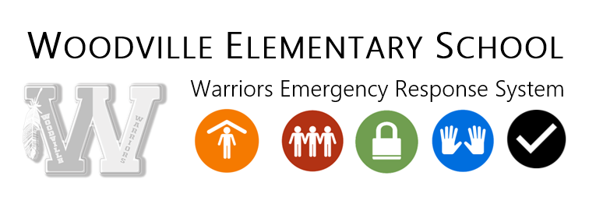

HEALTH

CONTAGIOUS/INFECTIOUS DISEASE
When a contagious/infectious disease is reported in a student’s classroom within Woodville Union Elementary School District, a written notification of the disease may be provided to each parent of student within that classroom. The contagious/ infectious diseases may include, but not be limited to, chicken pox, measles and pediculosis (head lice). To verify the presence of these contagious/ infectious diseases, the school nurse or health office clerk will conduct a physical examination of the child(ren) in question. A parent or guardian of any child(ren), has the right to refuse consent for physical examination of their child(ren), by annually providing a signed statement to that effect to the school site. This statement will exempt students from any physical exams; but whenever there is reason to believe that the child is suffering a recognized contagious or infectious disease, that child(ren) will be sent home and shall not be permitted to return until the school authorities are satisfied that any contagious/infectious disease does not exist. Woodville Union Elementary School District has a “no live nits” policy with regard to head lice.

HEALTH INSURANCE PRIVACY PRACTICES ACT (HIPPA)

NOTICE OF PRIVACY PRACTICES FOR THE USE AND DISCLOSURE
OF PRIVATE HEALTH INFORMATION.

The Health Insurance Portability Act (HIPPA) is a federal law that is intended to standardize the communication of electronic health information between health care providers and health insurers. It requires the U.S. Department of Health and Human Services to develop a series of rules which will protect the privacy and security of individually identifiable health information. The Privacy Rule governs how covered entities may use and disclose Protected Health Information (PHI). PHI is information that we have created or received about your child’s past, present or future health or medical condition that could be used to identify him/her.

In the normal course of business, the district furnishes, bills or is paid for specific “health care” services provided to students. Under the law, the District is required to make sure that your child’s PHI is kept private. The District has in place safeguards to reasonably protect PHI from any intentional or unintentional use or disclosure that is a violation of the Privacy rule. We may disclose your child’s PHI for the following reasons:

- So your child can receive treatment. We may use and disclose your PHI to those who provide your child with limited health care services (vision/audio/scoliosis screenings; speech/psychological assessments, athletic physicals, counseling services) or who are involved in your child’s care, such as the school nurse, health aide, speech therapist, counselor, psychologist, etc. we may also disclose your child’s PHI so that health care can be offered or provided to him/her.

- To get payment for your treatment.
We may use and disclose your child’s PHI in order to bill and get paid for treatment and services your child receives. For example, we may give parts of your PHI for a submission of a school-accident insurance-plan claim on behalf of the student.

- To report public health activities.
We share PHI with government officials in charge of collecting certain public health information.

- To meet legal requirements. We share PHI with government or law enforcement agencies when federal, state, or local laws require us to do so. For example, the law says we must report private information about children who have been abused or neglected.

Other uses and disclosures require your prior written agreement. In other situations, we will ask for your written permission before we use or disclose your PHI. You may decide later that you no longer want to agree to certain use of your PHI for which we received your permission. If so, you may tell us that in writing. We will then stop using your PHI for that certain situation.

Health screening examination (§ Safety Code 124100)
(a) In cooperation with the county child health and disability prevention program, the governing body of every school district or private school that has children enrolled in kindergarten shall provide information to the parents or guardians of all children enrolled in kindergarten of this article and Section 120475.
(b) Each county child health and disability prevention program shall reimburse school districts for information provided pursuant to this section. The Superintendent of Public Instruction may withhold state average daily attendance funds to any school district for any child for whom a certification or parental waiver is not obtained as required by Section 124085 (Amended by Stats. 2004, Ch. 895, Sec. 15.).

PHYSICAL EXAMINATIONS
All pupils are required to receive a physical examination within 18 months before entering the first grade. This examination may be obtained from your family physician or through the Child Health and Disability Program (CHDP) offered by several local providers. Information and forms are distributed to those pupils enrolled in kindergarten or may be obtained upon request at the front office of your child’s school.

PARENT’S REFUSAL TO CONTENT (§ 48980,49451; 20 USC 1232h)
A parent or guardian having control or charge of any child enrolled in the public schools may file annually with the principal of the school in which he is enrolled a statement in writing, signed by the parent or guardian, stating that he will not consent to a physical examination of his child. Thereupon, the child shall be exempt from any physical examination, but whenever there is a good reason to believe that the child is suffering from a recognized contagious or infectious disease, he shall be sent home and shall not be permitted to return until the school authorities are satisfied that any contagious or infectious disease does not exist.

IMMUNIZATIONS
Immunization for Communicable Disease - (H. & S. Code § 1203235, 120365, 120370 Education Code 48216; 17, CCR 6040)

The governing board of Woodville Union Elementary School District shall require that every child entering a school must be fully immunized against Diphtheria, Haemophilus influenza type b, Measles, Mumps, Pertussis (whooping cough), Poliomyelitis, Rubella, Tetanus, Hepatitis B, Varicella (chicken pox), and any other disease deemed appropriate by the California Department of Public Health. A written immunization record of each required vaccine, including date and provider must be presented at school entry.

- Commencing July 1, 2011, the governing board of Woodville Union Elementary School District shall require full immunization against Hepatitis B for any pupil entering the 7th grade level. Also commencing July 1, 2011, the governing board shall require any pupil entering 7th through 12th grade, inclusive, to be fully immunized against pertussis, including all pertussis boosters (Tdap) appropriate for the pupil's age.

- The governing board of the district shall notify the parent or guardian of the pupil that they have two weeks to supply evidence either that the pupil has been properly immunized, or that the pupil is exempted from the immunization requirement pursuant to Section 120365 or 120370 of the Health and Safety Code. An immunization waiver form is included in the enrollment packet for all students enrolling in WUSD who want to claim an immunization exemption. This waiver form must be completed and signed by the student’s physician. This includes exemptions for both medical reasons and personal beliefs. Forms can be obtained at the front office of each school.

- The governing board of the district, in the notice, shall refer the parent or guardian of the pupil to the pupil’s usual source of medical care to obtain the immunization, or if no usual source exists, either refer the parent or guardian to the county health department, or notify the parent or guardian that the immunizations will be administered at the school of the district.
Immunizations may be obtained from your family physician or Woodville’s local health clinics.

PERSONAL BELIEFS EXEMPTION (PBE) LAW
SB 277 Governor Brown signed Senate Bill (SB) 277 on June 30, 2015 which changes immunization
requirements for children entering child care or school. Effective January 1, 2016

- Parents or guardians of students in any school or child-care facility, whether public or private, will no longer be allowed to submit a personal beliefs exemption to a currently-required vaccine.
- Students will no longer be required to have immunizations for entry if they attend:
- A home-based private school or
- An independent study program with no classroom-based instruction.
For more information, refer to: http://www.shotsforschool.org/laws/sb277faq/#Q17A

COOPERATION IN CONTROL OF COMMUNICABLE DISEASE & IMMUNIZATION OF PUPILS (§ 49403)
The governing board of any school district may permit a licensed physician and surgeon, or a health care practitioner (including a physician assistant, nurse practitioner, registered nurse, licensed vocation nurse or nursing student who is acting under the supervision of a registered nurse as provided by law) who is acting under the direction of a supervising physician and surgeon, to administer an immunizing agent to a pupil whose parent or guardian has consented in writing prior to administration of the immunizing agent.

STUDENT HAS BEEN EXCLUDED FROM SCHOOL (§ 48213)
If a pupil is excluded from attendance pursuant to Section 120230 of the Health and Safety Code or Section 49451 of this code, or if a principal or his or her designee determines that the continued presence of the child would constitute a clear and present danger to the life, safety, or health of a pupil or school personnel, the governing board is not required to send prior notice of the exclusion to the parent or guardian of the pupil. The governing board shall send a notice of the exclusion as soon as is reasonably possible after the exclusion (Added by Stats. 2005, Ch. 677, Sec. 31. Reference: Education Code 49451 Health and Safety Code 120230).

TB Skin Test
All pupils entering school for the first time must present evidence and results of a TB skin test given previous to the enrollment date.

Pupils 7-12th grade entering school from another county and who have never attended Tulare County Schools must have received a TB skin test within one year of the date of enrollment.

The TB skin test must show negative results for TB. If a student has a positive TB test, a negative chest x-ray is also required. The student with a positive TB test can be granted a conditional entrance of 30-45 days while the student waits for their chest x-ray results. If you have any questions, please contact the school nurse at 559-686-9713.

MEDICATION IN SCHOOL
Students are not permitted to carry medication while on campus without proper doctor permission and documentation. Every attempt should be made to take necessary medications before or after school. When necessary, medication may be administered to students at school through the school nurse’s office when the following criteria are met:
- The school has received a written notice from the physician identifying the student, the medication to be administered, the dosage, the method of administration of the medication, and the duration (day, week, month, etc.) of the administration of the medication.
- The medication received by the school is clearly labeled in the original container and stored in the nurse’s office.
- No over-the-counter medication may be sent to school. We are not allowed to give them, even with parental consent. Over the counter medications are aspirin, Tylenol, Motrin, cough syrups, etc., purchased at a drug store without a Prescription. If your child needs to take prescription medication in school, please bring it to the school office and sign the proper form. Be sure that the doctor sends a note with you or you will be required to return to his/her office and get one. Each school year, parents and doctors will need to fill out new forms to take medication in school, even if it is the same medicine your child took last year. It is your student’s responsibility to come to the office and get his/her medicine at the correct time. It is the student’s responsibility to report to the Health Clerk at the school's office at the appropriate time for their medication.

ANAPHYLAXIS TREATMENT ANNUAL NOTIFICATION TO PARENTS
California Education Code 49414 authorizes school districts to provide epinephrine auto-injectors to trained personnel to use to provide emergency medical aid to persons suffering from an anaphylactic reaction.

Anaphylaxis is a rapid, severe allergic response triggered by insect stings, foods, medications, latex materials, exercise, or in rare cases by unknown causes. This is a life-threatening allergic condition, requiring immediate treatment. Administering epinephrine to students during a medical emergency may help to insure the student’s health and safety at school. Therefore, the Tulare County Office of Education has adopted a policy for standing orders or provides life-saving epinephrine to students who are in need of such treatment.

This policy states that a credentialed, licensed school nurse or trained, unlicensed school staff, under the direct or indirect supervision of the credentialed school nurse (or supervisor of health), may administer epinephrine in the form of an epinephrine auto-injector during a severe, life-threatening allergic reaction. The epinephrine auto-injector rapidly delivers a pre-measured, sterile, single dose of epinephrine by direct injection through the skin. *If parents/guardians do not wish their child to receive this treatment, they must so indicate in writing within two weeks of the beginning of school.

PHYSCIAL EXAMINATION AND SCOLIOSIS SCREENING
State law requires school districts to notify parents of the availability, to children between birth and until 90 days after beginning first grade, of health screening provided pursuant to the child Health and Disability Prevention Program, administered by the County Health Department. State law requires school districts to obtain from each child, within 90 days of beginning first grade, either a certificate documenting that within the prior 18 months the child has received the appropriate health screening and evaluation services specified by law, or a waiver signed by the child's parent or guardian indicating that they do not want or are unable to obtain such services for the child.

The reasons should be included in the waiver. The school district is required to screen every 7th grade girl and 8th grade boy for scoliosis (curvature of the spine). The parent/guardian has the right to submit to the school a written request that the pupil not participate in this screening program. Parent/guardians have the right to sign an affidavit of a personal belief exempting their children from a physical examination, including vision, hearing, and scoliosis screenings.

PARENT’S REFUSAL TO CONSENT
A parent or guardian having control or charge of any child enrolled in the public schools may file annually with the principal of the school in which he is enrolled a statement in writing, signed by the parent or guardian, stating that he will not consent to a physical examination of his child. Thereupon, the child shall be exempt from any physical examination, whenever there is a good reason to believe the child is suffering from a recognized contagious or infectious disease, he shall be sent home and shall not be permitted to return until the school authorities are satisfied that any contagious or infectious disease does not exist.

CALIFORNIA COMPREHENSIVE SEXUAL HEALTH EDUCATION AND HIV/AIDS PREVENTION EDUCATION ACT (51930-51939, 48980).
All pupils in grades 7 and 8 will receive comprehensive sexual health education and HIV/AIDS prevention education from highly trained outside consultants. There are two primary purposes for providing comprehensive sexual health and HIV/AIDS prevention education:

- To provide a student with the knowledge and skills necessary to protect his/her sexual and reproductive health from unintended pregnancy and STDs;
- To encourage a pupil to develop healthy attitudes concerning adolescent growth and development; body image, gender roles, sexual orientation, dating, marriage, and family.
- The law requires that HIV/AIDS prevention education is taught once in middle school and once in high school, and states that if comprehensive sexual health education is taught, the District must abide by all tenets of Education Code (EC) 51933. The District may not pick and choose topics.
- “Comprehensive sexual health education” means education regarding human development and sexuality, including education on pregnancy, family planning, and sexually transmitted diseases (EC 51931).
- “HIV/AIDS prevention education” means instruction on the nature of HIV/AIDS, methods of transmission, strategies to reduce the risk of human immunodeficiency virus (HIV) infection, and social and public health issues related to HIV/AIDS (EC 51931).
- Abstinence shall be taught within the context of HIV/AIDS prevention education (EC 51934 (3), however, abstinence-only education is not permitted in California public schools. Written and audiovisual educational materials used in comprehensive sexual health education and HIV/AIDS prevention education are available for inspection.

Information regarding instruction and materials:
- Age appropriate
- All factual information presented shall be medically accurate and objective.
- Available on an equal basis to English learner pupils, consistent with the existing curriculum and alternative options for an English learner pupil
- Appropriate for use with pupils of all races, genders, sexual orientations, ethnic and cultural backgrounds, and pupils with disabilities
- Accessible to pupils with disabilities, including, but not limited to, the provision of a modified curriculum, materials and instruction in alternative formats, and auxiliary aids.

- Encourage a pupil to communicate with his or her parents or guardians about human sexuality.
- Teach respect for marriage and committed relationships.
- Teach that abstinence from sexual intercourse is the only certain way to prevent unintended pregnancy, teach that abstinence from sexual activity is the only certain way to prevent sexually transmitted diseases, and provide information about the value of abstinence while also providing medically accurate information on other methods of preventing pregnancy and sexually transmitted diseases.
- Provide information about sexually transmitted diseases including how sexually transmitted diseases are and are not transmitted, the effectiveness and safety of all federal Food and Drug Administration (FDA) approved methods of reducing the risk of contracting sexually transmitted diseases, and information on local resources for testing and medical care for sexually transmitted diseases.
- Provide information about the effectiveness and safety of all FDA-approved contraceptive methods in preventing pregnancy, including, but not limited to, emergency contraception.
- Provide pupils with skills for making and implementing responsible decisions about sexuality.
- Provide pupils with information on the law on surrendering physical custody of a minor child 72 hours or younger, pursuant to Section 1255.7 of the Health and Safety Code and Section 271.5 of the Penal Code.

Anonymous, voluntary and confidential research and evaluation tools to measure pupils’ health behaviors and risks, including tests, questionnaires, and surveys containing age-appropriate questions about the pupils’ attitudes concerning or practices relating to sex may be administered to pupils in grades 7 and 8. Parents or guardians shall be notified in writing and given the opportunity to review such tests, questionnaires and surveys.

Parents/guardian may request in writing that his or her child not receive all or part of the above comprehensive sexual health education or HIV/AIDS prevention education. A pupil shall not be subject to disciplinary action, academic penalty, or other sanction if the parent/guardian does not permit the pupil to receive the instruction. While the instruction is being delivered, an alternative educational activity shall be made available to those pupils whose parent/guardian have requested that they not receive the instruction.

Parents/guardians have a right to request a copy of Chapter 5.6 of the Education Code (commencing with Section 51930 et seq.) from their child’s school.

TYPE 2 DIABETES INFORMATION

In accordance with the California Department of Education, Education Code Section 49452.7 it is our responsibility as an educational agency to ensure parents of all incoming 7th grade students have received educational information related to Type 2 diabetes. This information was developed by California Department of Education in collaboration with the California Department of Public Health, American Diabetes Association, California School Nurses Organization, and Children’s Hospital of Orange County.

TYPE 2 DIABETES IS THE MOST COMMON FORM OF DIABETES IN ADULTS.
- Until a few years ago, type 2 diabetes was rare in children, but it is becoming more common, especially for overweight teens.
- According to the U.S. Centers for Disease Control and Prevention (CDC), one in three American children born after 2000 will develop type 2 diabetes in his or her lifetime.

TYPE 2 DIABETES AFFECTS THE WAY THE BODY IS ABLE TO USE SUGAR (GLUCOSE) FOR ENERGY.
- The body turns the carbohydrates in food into glucose, the basic fuel for the body’s cells.
- The pancreas makes insulin, a hormone that moves glucose from the blood to the cells.
- In type 2 diabetes, the body’s cells resist the effects of insulin, and blood glucose levels rise.
- Over time, glucose reaches dangerously high levels in the blood, which is called hyperglycemia.
- Hyperglycemia can lead to health problems like heart disease, blindness, and kidney failure.

RISK FACTORS ASSOCIATED WITH TYPE 2 DIABETES

It is recommended that students displaying or possibly experiencing the risk factors and warning signs associated with type 2 diabetes be screened (tested) for the disease.

RISK FACTORS
Researchers do not completely understand why some people develop type 2 diabetes and others do not; however, the following risk factors are associated with an increased risk of type 2 diabetes in children:
- Being overweight. The single greatest risk factor for type 2 diabetes in children is excess weight. In the U.S., almost one out of every five children is overweight. The chances are more than double that an overweight child will develop diabetes.
- Family history of diabetes. Many affected children and youth have at least one parent with diabetes or have a significant family history of the disease.
- Inactivity. Being inactive further reduces the body's ability to respond to insulin.
- Specific racial/ethnic groups. Native Americans, African Americans, Hispanics/Latinos, or Asian/Pacific Islanders are more prone than other ethnic groups to develop type 2 diabetes.
- Puberty. Young people in puberty are more likely to develop type 2 diabetes than younger children, probably because of normal rises in hormone levels that can cause insulin resistance during this stage of rapid growth and physical development.

WARNING SIGNS AND SYMPTOMS ASSOCIATED WITH TYPE 2 DIABETES
Warning signs and symptoms of type 2 diabetes in children develop slowly, and initially there may be no symptoms. However, not everyone with insulin resistance or type 2 diabetes develops these warning signs, and not everyone who has these symptoms necessarily has type 2 diabetes.
- Increased hunger, even after eating
- Unexplained weight loss
- Increased thirst, dry mouth, and frequent urination
- Feeling very tired
- Blurred vision
- Slow healing of sores or cuts
- Dark velvety or ridged patches of skin, especially on the back of the neck or under the arms
- Irregular periods, no periods, and/or excess facial and body hair growth in girls
- High blood pressure or abnormal blood fats levels

TYPE 2 DIABETES PREVENTION METHODS AND TREATMENTS
Healthy lifestyle choices can help prevent and treat type 2 diabetes. Even with a family history of diabetes, eating healthy foods in the correct amounts and exercising regularly can help children achieve or maintain a normal weight and normal blood glucose levels.
- Eat healthy foods. Make wise food choices. Eat foods low in fat and calories.
- Get more physical activity. Increase physical activity to at least 60 minutes every day.
- Take medication. If diet and exercise are not enough to control the disease, it may be necessary to treat type 2 diabetes with medication.
The first step in treating type 2 diabetes is to visit a doctor. A doctor can determine if a child is overweight based on the child's age, weight, and height. A doctor can also request tests of a child's blood glucose to see if the child has diabetes or pre-diabetes (a condition which may lead to type 2 diabetes).

TYPES OF DIABETES SCREENING TESTS THAT ARE AVAILABLE
- Glycated hemoglobin (A1C) test. A blood test measures the average blood sugar level over two to three months. An A1C level of 6.5 percent or higher on two separate tests indicates diabetes.
- Random (non-fasting) blood sugar test. A blood sample is taken at a random time. A random blood sugar level of 200 milligrams per deciliter (mg/dL) or higher suggests diabetes. This test must be confirmed with a fasting blood glucose test.
- Fasting blood sugar test. A blood sample is taken after an overnight fast. A fasting blood sugar level less than 100 mg/dL is normal. A level of 100 to 125 mg/dL is considered pre-diabetes. A level of 126 mg/dL or higher on two separate tests indicates diabetes.
- Oral glucose tolerance test. A test measuring the fasting blood sugar level after an overnight fast with periodic testing for the next several hours after drinking a sugary liquid. A reading of more than 200 mg/dL after two hours indicates diabetes.
Type 2 diabetes in children is a preventable/treatable disease and the guidance provided in this information sheet is intended to raise awareness about this disease. Contact your student's school nurse, school administrator, or health care provider if you have questions.

School Activities

ULTIMATE WARRIOR FIELD TRIP
To be eligible to attend the Ultimate Warrior Field Trip, students must meet the following criteria for each trimester:
Trimester 1 | Trimester 2 | Trimester 3
0 absences | < 2 absences | < 3 absences
> 3.0 GPA | > 3.0 GPA | > 3.0 GPA
No Ed Code 48900 violations | No Ed Code 48900 violations | No Ed Code 48900 violations

DANCES
To be eligible to attend a dance a student must be enrolled at WOODVILLE ELEMENTARY SCHOOL at the time of the dance and meet all eligibility requirements as established for student participation in extra-curricular activities. All students must possess a WOODVILLE ELEMENTARY SCHOOL ASB or WOODVILLE ELEMENTARY SCHOOL ID card.

Students must remain in the dance until they are ready to leave for the evening. No one will be readmitted after leaving a dance except students who need to use the bathroom. Dances which start shortly after an athletic event will last approximately two hours. Under no circumstance will a dance last beyond 10:00 PM, except the graduation dance. All dances will be supervised by school employees only.

SCHOOL ATHLETICS
All Woodville Elementary School athletes are expected to embrace outstanding sportsmanship, citizenship, and fair play.

In the Woodville Elementary School Athletics Handbook for Students and Parents, you’ll find the goals and objectives of our athletic program, the responsibilities of Woodville Elementary School athletes and their parents, and the Woodville Elementary School expectations for athletes and their parents. Because student-athletes are held to high standards of performance, citizenship, and sportsmanship during school and non-school functions, acceptance of these responsibilities and expectations to self and to the team is mandatory.

Parental support for athletes in these training and academic standards is a most important element in maintaining the athletic and academic balance and competitiveness. Refer to the Woodville Elementary School Athletics Handbook for Students and Parents for more information.

PARENT VOLUNTEERS
Parent volunteers in the classroom provide an extra pair of hands, a caring individual who can offer needed one-on-one academic support, or perhaps a listening ear. When parents participate in school, all students benefit. If you are interested in volunteering please call the school and speak with your student’s teacher, principal, or designee. Recently, our Board of Trustees has strengthened procedures to protect the safety of students and adults. Volunteer service in the Woodville Elementary School District is now categorized by the amount of time and level of student contact. Volunteer service is categorized according to the following matrix:

Type | Description | Example | Requirements | Restrictions
Level 1 | Parents, immediate adult family members including grandparents, aunts, uncles and adult aged siblings in a specific classroom | One time projects; i.e. room parent; not regularly scheduled volunteer service. Participation of less than 4 hours per month. Field trips that do not include overnight stay. | 1. No district requirements | No unsupervised contact with students.
Level 2 | Parents, immediate adult family members including grandparents, aunts, uncles and adult aged siblings in a specific classroom | Regularly scheduled volunteer service that is performed within a classroom or elsewhere on the school premises. Generally, between 4-10 hours per month | 1. Megan’s Law Clearance  2. Copy of Driver’s License  3. Tuberculosis Test  4. District Application  5. Volunteer Orientation | No unsupervised contact with students.
Level 3 | Parents, Grandparents College students, Classroom volunteers, parent outside of child’s classroom | Regular or scheduled service generally exceeding 10 hours per month; i.e. overnight fieldtrips | 1. Megan’s Law Clearance  2. Copy of Driver’s License  3. Tuberculosis Test  4. Fingerprint Clearance  5. District Application  6. Volunteer Orientation | Limited unsupervised contact with students; generally, works under the direction of a teacher.

USE OF MEDIA FACILITIES
LIBRARY COMPUTER/MEDIA LAB RULES
Students are limited to checking-out a maximum of two books at a time.

Students may check-out books for their personal use only. Students may not check-out books for other students. A student may check-out library materials only when all previously checked-out library materials have been returned and all library fines have been paid. Books are checked out for 15 school days and if returned late will incur a 25 cent per school day fine, payable upon the book’s return.

Reference books may not be checked out and must be kept within the library at all times. Students disrupting the library environment will be asked to leave. Library books/materials must be returned directly to the Librarian in order to guarantee credit for the returned materials. Books left on counters, shelves, or other surfaces in our library may not be credited as returned.

Use of the Computer Lab is restricted to classes accompanied by a teacher, or teaching assistant. See below a list of requirements.
- To use computers, you must have a valid Internet Contract signed and on file. This will be verified before use is allowed.
- Students must observe all posted rules while using the computers.
- Food or drink of any kind, including candy and gum, are not permitted in the computer lab.

CAMPUS FACILITIES/ATHLETIC FIELDS
Use of all School Facilities is limited to activities sponsored by WOODVILLE ELEMENTARY SCHOOL. All other use must be approved by using the appropriate School District forms and approval process.

School Compact

School-Student-Parent-Teacher-Administrators Compact

STUDENTS
- Come to school regularly and on time.
- Take responsibility for their own learning.
- Work cooperatively with other students.
- Come to school ready to learn and to work hard.
- Bring necessary materials, completed assignments and homework.
- Respect my school, my classmates, my teachers, and others.
- Know and follow school and class rules.

PARENTS
- Make child’s education a priority.
- Prompt and regular attendance of my child.
- Supervise homework.
- Meet my child’s physical needs (i.e. clean, fed, proper sleep, etc.)
- Support school and district policies.
- Communicate with school by keeping emergency information current.
- Be visible and active in school activities.
- Attend parent/teacher conferences.

TEACHERS
- Report student progress.
- Conference with parents.
- Provide a quality education.
- Provide a safe and positive learning environment.
- Provide opportunities for parents to learn how to help their child.
- Assign appropriate homework.
- Involve the community.
- Support special school activities and programs.
- Communicate regularly with parents.
- Be attentive to students’ individual and diverse needs.
- Participate in professional growth activities.

ADMINISTRATORS
- Inform students and parents about school and district discipline standards.
- Consistently monitor classroom, school, and district rules.
- Counsel with students and parents regarding disciplinary matters.
- Provide professional growth experiences that will assist staff in increasing competencies for student control and discipline.
- Provide leadership that will establish, encourage, and promote good teaching and effective learning.

Laws, Procedures, and Legal Info

PUPIL RECORDS
Pupil records consist of personal identifying information, subjects taken, grades received, standardized test results, attendance records, and health records, and are maintained at the school the pupil attends. The district superintendent/school principal or designee is responsible for maintaining each type of pupil record and the information contained therein. Additional records, such as psychological and special education reports, may be maintained separately.

(a) The policy of the district for reviewing and expunging those records is that the parents and guardians
may review records during regular school hours with the help of certificated staff when requested (AR5125F).
(b) Pupil records are accessible only to parents or legal guardians, a pupil 16 years or older who has
completed the 10th grade, and school district personnel who have a legitimate educational interest in the child. School district personnel having access to pupil records would include governing board members, district certificated employees and administrators. A legitimate educational interest, according to board policies, is one held by officials and employees whose duties and responsibilities to the district require that they have access to students' records. The custodian of records shall determine whether the person seeking access meets the required criteria.
(c) Parents/guardians have the right to review and challenge the contents of their child's records. The
procedure for challenging the content of pupil records is that the parent/guardian may file with the superintendent a written request to remove information from his/her child's records. (AR 51251) Copies of the pupil record may be obtained by the parent/guardian. The school district shall reproduce copies of pupil records requested by parents/guardians, and the cost, if any, will be charged to the parent for such reproductions. (AR5125G) The location of the log required to be kept pursuant to Ed. Code 49064 is in each school site office under the supervision of the site administrator.
(d) Parents have the right to file a complaint with the United States Department of Health, Education,
and Welfare concerning alleged failure by the district to comply with the provisions of #438 of the General Education Provisions Act (20 U.S.C. #1232G).

TEACHER/PARAPROFESSIONAL QUALIFICATIONS
Parents are entitled, at their request, to be informed regarding the professional qualifications of their child’s teacher or classroom paraprofessional. To make such inquiry, parents should contact the school’s principal.

SPECIAL EDUCATION
To provide a specially designed instructional program to meet the unique needs of individuals with exceptional needs, whose educational requirement cannot be met with a modification of the regular instructional program, the district will provide a special instructional program at no cost to the parent. Qualified students with disabilities, ages 3-21, will be offered a free and appropriate public education (FAPE) in a least restrictive environment.

The Superintendent or designee has established a means whereby parents/guardians, teachers and others may request screening for any child they believe to have a disability that significantly interferes with his/her learning. The Superintendent or designee has implemented screening processes to determine when an individual’s academic, behavior or other difficulties may be related to disabilities and shall establish systematic procedures for special education program identification, screening, referral, assessment, planning, implementation, review and triennial assessment.

For assessment purposes, staff shall use appropriate tests to identify specific information about the student’s abilities in skill areas. In addition, staff shall use multiple measures, including direct observation, to study the effect of interventions or modifications to the regular instructional program. Staff also may consider the student’s personal history, development and adaptive behavior. The Superintendent or designee notifies parents/guardians in writing of their rights related to identification, referral, and assessment, instructional planning, implementation and review, including the district’s procedures for initiating a referral for assessment to identify individuals who need special education services.

Any individual, public agency or organization may file a written complaint with the district superintendent or with the state superintendent of public instruction if they believe the school district has violated federal or state laws regarding special education.

The following procedures shall be used to address all complaints, which allege that the district has violated federal or state laws or regulations governing educational programs. The complaint shall be presented to the Superintendent or designee, who shall then give it to the appropriate compliance officer. The compliance officer shall hold an investigative meeting within five days of receiving the complaint.

Within 30 days of receiving the complaint, the compliance officer shall prepare and send to the complainant a written report of the district’s investigation and decision. If the complainant is dissatisfied with the compliance officer’s decision, he/she may, within five days, file his/her complaint in writing with the Board. If the Board
hears the complaint, the compliance officer shall send the Board’s decision to the complainant within 60 days of the district’s initially receiving the complaint. A detailed statement of all specific issues that were brought up during the investigation and the extent to which these issues were resolved. If dissatisfied with the district’s decision, the complainant may appeal in writing to the California Department of Education within 15 days of receiving the district’s decision.

INDIVIDUALS WITH DISABILITIES EDUCATION ACT (IDEA)
“Every individual with exceptional needs, who is eligible to receive educational instruction, related services, or both under this part shall receive such educational instruction, services, or both, at no cost to his or her parents or, as appropriate, to him or her.” Federal law also requires a free and appropriate education in the least restrictive environment be offered to qualified handicapped pupils.

INDIVIDUAL INSTRUCTION FOR PUPILS WITH TEMPORARY DISABILITIES
A pupil with a temporary disability, who is in a hospital or residential health facility (excluding a state hospital), the pupil's home, or under other circumstances prescribed by regulations adopted for that purpose by the State Board of Education, shall be deemed to be a resident of the school district where the hospital is located. The parent/guardian has the primary responsibility to notify the school district in which the pupil with the temporary disability is deemed to reside because of hospitalization. The resident school district will offer individualized instruction if the pupil qualifies, unless the pupil's prior school district provides such individualized instruction.

ALTERNATIVE SCHOOL
California State law authorizes all school districts to provide for alternative schools, Section 58500 of the Education Code defines alternative school as a school or separate class group within a school which is operated in a manner designed to:
(a) maximize the opportunity for students to develop the positive values of self-reliance, initiative, kindness, spontaneity, resourcefulness, courage, creativity, responsibility, and joy;
(b) recognize that the best learning takes place when students learn because of their desire to learn;
(c) maintain a learning situation maximizing students' self-motivation and encouraging the students in their own time to follow their own interests. These interests may be conceived by them totally and independently or may result, in whole or in part, from a presentation by their teachers of choices of learning projects;
(d) maximize the opportunity for teachers, parents, and students to cooperatively develop the learning process and its subject matter. This opportunity shall be a continuous, permanent process;
(e) maximize the opportunity for the students, teachers, and parents to continuously react to the changing world including, but not limited to, the community in which the school is located.

In the event any parent, pupil, or teacher is interested in further information concerning alternative schools, the county superintendent of schools, the administrative office of this district, and the principal's office in each attendance area have copies of the law available for your information. This law authorizes interested persons to request the governing board of the district to establish alternative school programs in each district.

AVAILABILITY OF ACCIDENT INSURANCE
The school district will make available an optional accident insurance coverage that may be purchased by students. Purchase of this coverage is not mandatory. However, participation in after-school sports requires that students be covered by some form of insurance (BP5143AB).

MEGAN’S LAW
The Sheriff’s Department provides the district with information regarding serious sex offenders residing within a three-mile radius of our schools. You must contact the local Sheriff’s Department to access this information.

RETENTION AND PROMOTION
The Woodville School District Promotion and Retention plan outlines the path by which decisions will be made to provide services for students whose academic performance demonstrates that he/she is not meeting district content standards in the current grade level.

This plan focuses on early identification of at-risk students. Teachers, administrators and parents for each at-risk student will design a Strategic Learning Intervention Plan. This SLIP will describe the services, strategies and responsibilities of all parties involved in the students’ success. Students will be reassessed near the end of the school year at which time a determination, based on district criteria, to retain or promote will be made.

The State of California has been focusing on the issue of the responsibility of the students for years. Too many students are not successful in middle school and high school because their skills in reading, mathematics and language and literature are not enough to enable them to successfully complete the class work. These students have not been able to master the skills of grade level and are not advanced.

Several of the non-advanced students were promoted socially from one grade to the next hoping that with time the students would learn the necessary skills for their grade level. Unfortunately, this did not happen. Often, students delayed more and more. Even if students showed growth, several remained below their grade level.

New laws now require that school districts focus on the serious problem of non-advanced students. AB 1626, promotion and retention of students, requires all school districts to establish a promotion and retention

policy based on the achievement of students of grade level standards. In addition, AB 1639 requires school districts to provide supplemental instruction to students in grades 2-8 with low achievement in reading, writing and mathematics.

HOW WILL MY CHILD BE AFFECTED?
At the beginning of the school year, all students will be assessed in reading, writing and mathematics. If your child is in danger of being retained, based on the criterion of the district, you will be notified by your child’s teacher by the first Parent/Teacher conference. An intervention plan will be agreed upon between the parents, teachers, staff and administrators of resources in order to improve the chances of success of your child. This intervention plan will include opportunities in class as well as opportunities during extended day(s). It is very important to follow this plan of intervention.

In the spring, you and your child's teacher should review the plan and the evaluations that have been given to the child during the year and determine if your child will be promoted to the next grade or whether they will need to be retained. It will be important that parents remain closely connected to the education of their children and that all work together to ensure the success of the student.

WHAT CAN PARENTS DO?
- Ask your child's teacher what are the math, reading and writing skills that have not been met by your child.
- Ask your child's teacher to share how you can help your child and their needs with a supplemental program of instruction.
- Make arrangements so your child can attend programs that are designed to help students who are in danger of being retained.
- Establish regular schedules of the days and weeks so that you work with your child in the skills they need to learn.
- Explain to your child that you will help him/her at home, and how the school will help support your child is successful.
- Praise your child when they do good work.
- Carefully monitor the progress of your child. If your child continues to struggle, contact your teacher.

15.8 NONDISCRIMINATION INFORMATION
District programs shall be free from discrimination based on gender, sex, age, race, color, religion, ancestry, national origin, ethnic group identification, marital or parental status, physical or mental disability, medical condition, sexual orientation or any actual or perceived characteristic that is contained in the definition of hate crime set forth in Penal Code section 422.55, or the perception of one or more of such characteristics or lack of English skills.

Title IX requires each school district that receives federal funds to have a Title IX coordinator, to notify all students and employees of the name, office address, and telephone number of the designated coordinator, and to adopt and publish a grievance procedure to resolve student and employee complaints under Title IX.

UNIFORM COMPLAINT PROCEDURES
The governing Board recognizes that the district is responsible for ensuring that it complies with state and federal laws and regulations governing education programs. The district shall follow uniform complaint procedures when addressing complaints alleging unlawful discrimination based on ethnic group identification, religion, age, gender, color, or physical or mental disability in any program or activity that receives or benefits from state financial assistance. The district shall also follow uniform complaint

procedures when addressing complaints alleging failure to comply with state or federal law in adult
basic education, consolidated categorical aid programs, migrant education, vocational education, child care and development programs, child nutrition programs and special education programs. The Board encourages the early, informal resolution of complaints at the site level whenever possible. Upon receipt of a written complaint from an individual, public agency or organization, uniform complaint procedures shall be initiated. The Superintendent or designee shall distribute full information about these procedures.

The Board recognizes that a neutral mediator can often suggest an early compromise that is agreeable to all parties in a dispute. In accordance with uniform complaint procedures, whenever all parties to a complaint agree to try resolving their problem through mediation, the Superintendent or designee shall initiate a mediation process before beginning a formal compliance investigation.

The Superintendent or designee shall ensure that mediation results are consistent with state and federal laws and regulations. The Board acknowledges and respects students and employee rights to privacy. Discrimination complaints shall be investigated in a manner that protects the confidentiality of the parties and the facts. This includes keeping the identity of the complainant confidential except to the extent necessary to carry out the investigation or proceedings, as determined by the Superintendent or designee on a case-by-case basis.

The Board prohibits retaliation in any form for the filing of a complaint, the report of instances of discrimination or participation in complaint procedures. Such participation shall not in any way affect the status, grades or work assignments of the complainant (AR1312.3).

Compliance officers
The Governing Board designates the following compliance officers to receive and investigate complaints and ensure district compliance with law:
District Superintendent
16563 Road 168
Porterville, CA 93257
(559) 686-9712

The Superintendent or designee shall ensure that employees designated to investigate complaints are knowledgeable about the laws and programs for which they are responsible. Such employees may have access to legal counsel as determined by the Superintendent or designee.

NOTIFICATIONS
The Superintendent or designee shall meet the notification requirement of the Code of Regulations, Title 5, Section 4622, including the annual dissemination of district complaint procedures and information about available appeals, civil law remedies and conditions under which a complaint may be taken directly to the California Department of Education.

The Superintendent or designee shall ensure that complainants understand that they may pursue other remedies, including actions before civil courts or other public agencies. The above notification shall state that complainants may seek help from agencies such as legal assistance agencies, local mediation centers or the County Office of Education.

Local resources include:
Tulare County Office of Education Central California Legal Services Inc.
6200 S, Mooney Blvd. 208 W. Main Street, Suite U
Visalia, CA 93278 Visalia, CA 93291
(559) 733-6300 (559) 733-8770

COMPLAINT PROCEDURES
The following procedures shall be used to address all complaints, which allege that the district or school has violated federal or state laws or regulations governing educational programs. Compliance officer shall maintain a record of each complaint and subsequent related actions, including all information required for compliance with the Code of Regulations, Title 5, Section 4632.All parties involved in allegations shall be notified when a complaint is filed, when a complaint meeting or hearing is scheduled and when a decision or ruling is made.

Step 1: Filing of Complaint
Any individual, public agency or organization may file a written complaint of alleged noncompliance by the district. A person who alleges that he/she personally suffered unlawful discrimination or a person who believes that has subjected an individual or any specific class of individuals to unlawful discrimination may file complaints alleging unlawful discrimination. The complaint must be initiated no later than six months from the date when the alleged discrimination occurred or when the complainant first obtained knowledge of the facts of the alleged discrimination (Title 5, Section 4630).

The complaint shall be presented to the compliance officer who shall maintain a log of complaints received, providing each with a code number and a date stamp. If a complainant is unable to put a complaint in writing due to conditions such as illiteracy or other disabilities, district staff shall help him/her to file the complaint (Title 5, Section 4600).

Step 2: Mediation
Within three days of receiving the complaint, the compliance officer may informally discuss with the complainant the possibility of using mediation. If the complainant agrees to mediation, the compliance officer shall make all arrangements for this process. Before initiating the mediation of a discrimination complaint, the compliance office shall ensure that all parties agree to make the mediator a party to related confidential information. If the mediation process does not resolve the problem within the parameters of law, the compliance office shall proceed with his/her investigation of the complaint.

The use of mediation shall not extend the district’s timelines for investigation and resolving the complaint unless the complainant agrees in writing to such an extension of time (Title 5, Section 4631).

Step 3 Investigation of Complaint
The compliance officer shall hold an investigative meeting within five days of receiving the complaint of an unsuccessful attempt to mediate the complaint. This meeting shall provide an opportunity for the complainant and/or his/her representative to repeat the complaint orally.

The complainant and/or his/her representative and the district’s representatives shall also have an opportunity to present information relevant to the complaint. Parties to the dispute may discuss the complaint and question each other or each other’s witnesses (Title 5, Section 4631).

Step 4: Response
Within 30 days of receiving the complaint, the compliance officer shall prepare and send to the complainant a written report of the district’s investigation and decision, as described in Step #5 below; If the complainant is dissatisfied with the compliance officer’s decision, he/she may, within five days, file his/her complaint in writing with the Board.

The Board may consider the matter at its next regular Board meeting or at a special Board meeting convened in order to meet the 60-day time limit within which the complaint must be answered. The board may decide not to hear the complaint, in which case the compliance officer’s decision is final. If the Board hears the complaint, the compliance officer shall send the Board’s decision to the complainant within 60 days of the district’s initially receiving the complaint or within the time period that has been specified in a written agreement with the complainant (Title 5, Section 4631).

Step 5: Final Written Decision
The report of the district’s decision shall be written in English and in the language of the complainant whenever feasible or required by law. If it is not feasible to write this report in the complainant’s primary language, the district shall arrange a meeting at which a community member will interpret it for the complainant.

This report shall include:
- The findings and disposition of the complaint, including corrective actions, if any (Title 5, Section 4631)
- The rationale for the above disposition (Title 5, Section 4631)
- Notice of the complainant’s right to appeal the decision to the California Department of Education, and procedures to be followed for initiating such an appeal (Title 5, Section 4631)
- A detailed statement of all specific issues that were brought up during the investigation and the extent to which these issues were resolved.
If an employee is disciplined as a result of the complaint, this report shall simply state that effective action was taken and that the employee was informed of district expectations. The report shall not give any further information as the nature of the disciplinary action.

WILLIAMS UNIFORM COMPLAINT PROCEDURES
The district has established policies and procedures regarding deficiencies related to textbooks and instructional materials, emergency or urgent facilities conditions that pose a threat to the health and safety of students or staff, and teacher vacancy or mis-assignment and intensive instruction and services provided pursuant to Section 37254 to pupils who have not passed one or both parts of the high school exit examination after the completion of grade 12.

Filing of Complaint
A complaint alleging any condition(s) specified above shall be filed with the principal or designee at the school in which the complaint arises. The principal or designee shall forward a complaint about problems beyond his/her authority to the Superintendent or designee in a timely manner, but not to exceed 10 working days (Education Code 35186; 5 CCR 4680).

The principal or designee shall make all reasonable efforts to investigate any problem within his/her authority. He/she shall remedy a valid complaint within a reasonable time period not to exceed 30 working days from the date the complaint was received (Education Code 35186).

Complaints may be filed anonymously. If the complainant has indicated on the complaint form that he/she would like a response to the complaint, the principal or designee shall report the resolution of the complaint to him/her within 45 working days of the initial filing of the complaint. If a response is requested, the response shall be made to the mailing address of the complainant as indicated on the complaint form. At the same time, the principal or designee shall report the same information to the Superintendent or designee (Education Code 35186; 5 CCR 4680).

If a complainant is not satisfied with the resolution of a complaint, he/she has the right to describe the complaint to the Governing Board at a regularly scheduled meeting (Education Code 35186; 5 CCR 4686).
For any complaint concerning a facility condition that poses an emergency or urgent threat to the health or safety of students or staff as described in item #3 above, a complainant who is not satisfied with the resolution proffered by the principal or Superintendent or designee may file an appeal to the Superintendent of Public Instruction (SPI) within 15 days of receiving the district’s response. The complainant shall comply with the appeal requirements specified in 5 CCR 4632 (Education Code 35186; 5 CCR 4687).

All complaints and written responses shall be public records (Education Code 35186; 5 CCR 4686).
The Governing Board designates the following compliance officers to receive and investigate complaints and ensure district compliance with the law:
Superintendent
16563 Road 168
Porterville, CA 93257
(559) 686-9712

APPEALS TO THE CALIFORNIA DEPARTMENT OF EDUCATION
If dissatisfied with the district’s decision, the complainant may appeal in writing to the California Department of Education within 15 days of receiving the district’s decision. For good cause, the Superintendent of Public Instruction may grant an extension for filing appeals (Title 5, 4652).

When appealing to the California Department of Education, the complainant must specify the reasons for appealing the district’s decision and must include a copy of the locally filed complaint and the district’s decision (Title 5, Section 4652).

AIR QUALITY POLICY
The Air Quality Control District notifies school districts when poor air quality exceeds designated levels and prescribed limitations on pupil activities are advised. Excessive activity in high temperatures can be unhealthful for children (and adults). The district has in place a response action plan (a copy of these guidelines can be obtained in your child’s school office), as well as the poor air quality definitions (as designated by the Air Quality Control District), and an excessive heat definition. School sites will be notified when these limits have exceeded the thresholds designated by the Air Quality Control District.

WRITTEN PARENTAL OBJECTIONS
Parental objections made in writing by parents/guardians relating to any of the aforementioned areas must be submitted on an annual basis to the site principal.

THE ASBESTOS HAZARD EMERGENCY RESPONSE ACT (AHERA):
"The Hazards of Asbestos"-Many workers in the asbestos mining and manufacturing industries have developed lung disease and various kinds of cancers as a direct result of their exposure to airborne asbestos
fibers. When inhaled, these asbestos fibers can become embedded in lung tissue where they can cause a variety of diseases such as asbestoses, mesothelioma, and lung cancer. The relationship between exposure level and health risk is complex. The available data indicates that the risk of these illnesses increases in direct proportion to the increase in asbestos exposure (i.e., the more asbestos you inhale, the higher the risk of disease).

"Methods used to reduce the potential of exposure to asbestos"
We at the Woodville Union School District have inspected all of our school buildings using an AHERA certificated inspector and have drawn up management plans that outline what we are doing to prevent exposure of our students, teachers, and employees to airborne asbestos. The management plan our school in the district is available for review at the school office. We are continuing to inspect possible asbestos containing building material however all known asbestos materials have been removed.
The school's management plan identifies all areas identified as containing asbestos-containing building material and those areas that are assumed, but not proven, to contain ACBM. All friable material (asbestos that will crumble under hand pressure and can be released into the air) has been identified and removed by properly licensed asbestos abatement contractors. Please feel free to contact the Supervisor of Maintenance and Operations.

18.0 HEALTHY SCHOOLS ACT

Dear Parent or Guardian,
The Healthy Schools Act of 2000 was signed into law in September 2000 and requires that all schools provide parents or guardians of students with annual written notification of expected pesticide use on school sites. The notification will identify the active ingredient or ingredients in each pesticide product and will include the Internet address (http://www.cdpr.ca.gov) for further information on pesticides and their alternatives.

Woodville School District will be using the following products:

Product Active Ingredient/EPA#
Demand CS Lambda-Cyhalothrin / 100-1066
Demon TC Cypermethrin Technical / 100-1006
Trimec Plus Monosodium Acid Methanearsonic / 2217 709
Oryzalin 4Pro Oryzalin / 72167-15-73220
Activator 85 Alkyl Aryl Polyoxyethylene glycol /1050990-50016AA
Honcho
Plus Isopropylamine Salt of Glyphosate / 524 445
Wilco Gopher Bait (AG) Solicam
Wilco Ground-Squirrel Bait .005% Chlorophacinone Demon Max Cypermethrin Termidor
Fipronil
Cykick Cyfluthrin P.T. 565 Pyrethrins D.Force H.P.X
Deltamethrin
Maxforce ant killer bait gel Fipronil
Suspend CS Deltamethrin Talstar Bifenthrin
Non Pesticides: Glue-boards for mice/rats

19.0 STUDENT ACCIDENT INSURANCE

Dear Parents:

The Woodville Union School District does not provide medical, accident or dental insurance for pupils injured on school premises or through school activities. To help you provide coverage for your child, the District is making available a low cost medical/dental accident insurance program. The purpose of this plan is to provide assistance at a minimum cost to meet some of the expenses for accidental injury. The plan does not provide unlimited coverage, but does offer substantial assistance in the event of injury.
Please visit your Childs’ School Office to obtain a detailed brochure/application, or you may obtain one and sign up online at www.peinsurance.com (click on Products, then Student Insurance). Please read the Student Benefits Plan Brochure to select the plan that best meets your needs.

20.0 INTERNET ACCEPTABLE USE AND SAFETY POLICY (IAUSP)
Updated on July 1, 2013
Board Approved on: July 9, 2013
20.1 THE POLICY
- Woodville Union School District (“WUSD”) provides access to the Internet for its employees, agents, students, and volunteers, collectively referred to as “users” for educational and business purposes, in conformance with applicable law. This Internet Acceptable Use and Safety Policy (“policy”) governs all electronic activity of users using and accessing the WUSD’s Internet systems, including WUSD e-mail and WUSD-provided access to the Internet, and applies to the use of the WUSD Internet Systems both on and off WUSD property.
- “The WUSD’s Internet Systems” means WUSD-provided devices, Internet connections (including wireless connections) provided by the WUSD, WUSD-provided e-mail accounts, intranet and any remote connection to WUSD systems. A user is deemed to access and use the WUSD’s Internet Systems through any electronic activity conducted on the WUSD’s Internet Systems using any device (whether or not such device is a WUSD-provided device) regardless of the user’s physical location.
- “WUSD-provided devices” means any electronic device provided by the WUSD, including, but not limited to, desktop computers, laptops, and hand-held devices, such as personal digital assistants (PDAs), smartphones, iPads, tablets and e-readers.
- Student use of the WUSD’s Internet Systems is governed by this policy, WUSD regulations, policies and guidelines, the WUSD Standards of Conduct and Uniform Disciplinary Measures (the “Discipline Code”) and applicable law. Employee use is governed by this policy, WUSD regulations, policies and guidelines, the WUSD’s employment policies, applicable collective bargaining agreements and applicable law.
- By using the WUSD’s Internet Systems, a user agrees to follow this policy and all applicable WUSD regulations, policies and guidelines. All users must report any misuse of the network or Internet or receipt of any communication that violates this policy to a teacher, supervisor or other appropriate WUSD personnel.

PRINCIPALS OF ACCEPTANCE AND SAFE INTERNET USE
General
Internet access and e-mail provided by the WUSD are intended for educational use, instruction, research and the facilitation of communication, collaboration, and other WUSD related purposes. Users are subject to the same standards expected in a classroom and/or professional workplace.
Monitoring and Privacy
Users have no right to privacy while using the WUSD’s Internet Systems. The WUSD monitors users’ online activities and reserves the right to access, review, copy, store, or delete any electronic communications or files. This includes any items stored on WUSD-provided devices, such as files, e-mails, cookies, and Internet history.
The WUSD reserves the right to disclose any electronic activity, including electronic communications, to law enforcement officials or third parties, as appropriate and consistent with applicable law. The WUSD will fully cooperate with local, state, or federal officials in any lawful investigation concerning or relating to any illegal activities conducted through the WUSD’s Internet Systems.
Prohibited Uses of the WUSD’s Internet Systems
Users may not engage in any of the activities prohibited by this policy when using or accessing the WUSD’s Internet Systems.
If a user is uncertain whether behavior is prohibited, he or she should contact a teacher, supervisor or other appropriate WUSD personnel. The WUSD reserves the right to take immediate action regarding activities that (1) create security and/or safety issues for the WUSD, students, employees, schools, network or computer resources, or (2) expend WUSD resources on content the WUSD determines lacks legitimate educational or WUSD content or purpose, or (3) the WUSD determines are inappropriate.
Below is a non-exhaustive list of examples of prohibited behavior:
- Causing harm to others, damage to their property or WUSD property, such as:
        - Using, posting or distributing profane, lewd, vulgar, threatening, or abusive language in e-mail messages, material posted on WUSD web pages, or professional social media sites;
        - Accessing, using, posting, or distributing information or materials that are pornographic or otherwise obscene, advocate illegal or dangerous acts, or advocate violence or discrimination. If users inadvertently access such information, they should immediately disclose the inadvertent access in a manner specified by WUSD;
        - Accessing, posting or distributing harassing, discriminatory, inflammatory, or hateful material, or making damaging or false statements about others;
        - Sending, posting, or otherwise distributing chain letters or engaging in spamming;
        - Damaging computer equipment, files, data or the WUSD’s Internet System in any way, including spreading computer viruses, vandalizing data, software or
        - Equipment, damaging or disabling others’ electronic property, or engaging in conduct that could interfere or cause a danger of disruption to the WUSD’s educational or business environment;
        - Bypassing WUSD Internet Proxy, Firewall, or using connection anonymizing methods
        - Using the WUSD’s Internet System in a manner that interferes with the education of the user or others or the job duties of the user or others;
        - Downloading, posting, reproducing or distributing music, photographs, video or other works in violation of applicable copyright laws. Any music, photographs and/or video should only be downloaded for WUSD, and not personal purposes. If a work specifies how that work may be used, the user should follow the expressed requirements.
        - If users are unsure whether or not they can use a work, they should request permission from the copyright or trademark owner; or
        - Engaging in plagiarism. Plagiarism is taking the ideas or writings of others and presenting them as if they were original to the user.
2. Gaining or attempting to gain unauthorized access to the WUSD’s Internet Systems, or to any third party’s computer system, such as:
        - Malicious tampering, phishing or hacking activities;
        - Intentionally seeking information about passwords belonging to other users;
        - Disclosing a user’s password to the WUSD’s Internet Systems to other individuals. However, students may share their WUSD password with their parents.
        - Modifying passwords belonging to other users;
        - Attempting to log in through another person's account;
        - Attempting to gain access to material that is blocked or filtered by the WUSD;
        - Accessing, copying, or modifying another user’s files without authorization;
        - Disguising a user’s identity;
        - Using the password or identifier of an account that does not belong to the user; or
        - Engaging in uses that jeopardize access into others’ accounts or other computer networks.
3. Using the WUSD’s Internet Systems for commercial purposes, such as:
(a) Using the WUSD’s Internet Systems for personal financial gain;
  - Conducting for-profit business activities, personal advertising, or other non-WUSD
business communications;
  - Engaging in fundraising (except as set forth in the Chancellor’s Regulation A-610); or
  - Using the WUSD’s Internet Systems on behalf of any elected official, candidate,
candidates, slate of candidates or a political organization or committee.
4. Engaging in criminal or other unlawful activities.

20.3 FILTERING
In accordance to Children’s Internet Protection Act (“CIPA”), WUSD blocks or filters content over the Internet that WUSD considers inappropriate for minors. This includes pornography, obscene material, and other material that may be harmful to minors. WUSD may also block or filter other content deemed to be inappropriate, lacking educational or work-related content or that pose a threat to the network. WUSD may, in its discretion, disable such filtering for certain users for bona-fide research or other lawful educational or business purposes.
Users shall not use any website, application, or methods to bypass filtering of the network or perform any other unlawful activities.
20.4 PROTECTION OF PERSONALLY IDENTIFIABLE & CONFIDENTIAL INFORMATION
The Family Educational Rights and Privacy Act (“FERPA”) prohibits WUSD school officials from disclosing personally identifiable information (“PII”) from education records of WUSD students and families to third parties without parental consent. However, several exceptions to this general rule may apply.
All users of the WUSD’s Internet Systems must comply with FERPA, Confidentiality and Release of Student Records; Records Retention. If you are unsure about whether the activity will comply with FERPA, please contact the WUSD’s Superintendent.
Internal communications with a WUSD attorney may also be confidential. Accordingly, users should not forward or distribute such communications without first checking with the attorney. Users should ensure that e-mails that include or attach confidential information are only sent to the intended recipients.

STUDENT INTERNET SAFETY
1. WUSD Responsibilities:
  - WUSD will provide curriculum about appropriate online behavior, including interacting with other individuals on social networking websites and in chat rooms, and cyberbullying awareness and response.
  - WUSD will work to protect the safety and security of minors when using electronic mail, chat rooms, and other forms of direct electronic communications.
  - As appropriate, WUSD will provide students, staff and parents with guidelines and instructions for student safety while using the Internet.
- Students Using WUSD’s Internet Systems
  - Students must not reveal personal information about themselves or other persons on social networking sites, in chat rooms, in emails or other direct electronic communications, or any other forum over the Internet. For example, students must not reveal their home address, or telephone or cell phone number. Students must not display photographs of themselves, or the images of others.
  - Students should not meet in person anyone they have met only on the Internet.
  - Students must promptly disclose to their teacher or other school employee any message or other activity they receive that is inappropriate or makes them feel uncomfortable.
  - Students should not allow WUSD computers to save their passwords.
3. Teachers using the WUSD Internet Systems, including Social Media for class activities
- Teachers should educate students about appropriate and safe online behavior, including interacting with individuals on social networking websites and in chat rooms and cyberbullying awareness and response. Teachers should refer to the FBI’s Kids Safety Tips (http://www.fbi.gov/fun-games/kids/kids-safety) and other free educational Internet safety resources available on the Internet.
- Social Media
- “Social media” means any form of online publication or presence that allows interactive communication, including, but not limited to, social networks, blogs, internet websites, internet forums, and wikis. Examples of social media include, but are not limited to, Facebook, Snapchat, Twitter, YouTube, Myspace, Google+, and Flickr.
- Schools use a variety of online web-based interactive communication technologies to enhance students’ education and learning. Social media sites must be used only for educational and school related purposes, in connection with lessons and assignments and to facilitate communication with teachers and other students.
- WUSD limits access to these sites to individuals within the school and WUSD school officials. If access to a social media site will extend beyond individuals within the school or WUSD school officials, then parent consent is required.
- Teachers must refer to the WUSD’s Social Media Guidelines, which are incorporated into this policy, if Internet activities will involve social media.
4. Parents:
      - Although students generally will be supervised when using the WUSD’s Internet System on school property, it is not practicable for the WUSD to monitor and enforce a wide range of social values in student use of the Internet. Parents are primarily responsible for transmitting their particular set of family values to their children, and discussing with their children what material is and is not acceptable for their children to access through the WUSD’s Internet Systems.
      - Parents are exclusively responsible for monitoring their children's use of the Internet when the WUSD’s Internet Systems are accessed from home or a non-school location. The WUSD may or may not employ its filtering systems to screen home access to the WUSD’s Internet Systems. Parents should inquire with the school or WUSD.
Violations of this Policy
WUSD reserves the right to terminate any user’s access to WUSD Internet Systems - including access to WUSD e-mail - at any time.
If a student violates this policy, appropriate disciplinary action will be taken consistent with the WUSD Discipline Code. If a student’s access to the WUSD’s Internet System is revoked, the student may not be penalized academically, and the WUSD will ensure that the student continues to have a meaningful opportunity to participate in the educational program.
Employee violations of this policy will be handled by appropriate discipline.
All users must promptly disclose to their teacher, supervisor, principal or manager any information they receive that is inappropriate or makes them feel uncomfortable.

Limitation of Liability
WUSD makes no guarantees about the quality of the services provided and is not responsible for any claims, losses, damages, costs, or other obligations arising from use of the network or accounts. Any additional charges a user accrues due to the use of WUSD’s network are to be borne by the user. WUSD also denies any responsibility for the accuracy or quality of the information obtained through user access. Any statement, accessible on the computer network or the Internet, is understood to be the author's individual point of view and not that of the WUSD, its affiliates, or employees.
Copies of this Policy and Inquiries
The WUSD reserves the right to amend and/or revise this policy at any time as the need arises. This policy is available upon request and in soft copy. For the most up-to-date version of this policy please visit: www.woodville.k12.ca.us
EVERY STUDENT SUCCEEDS ACT (ESSA)
September 2017
Re: Parent/Guardian Right to Know of Teacher’s and Paraprofessional’s Professional Qualifications

Dear Parent/Guardian:
Every Student Succeeds Act (“ESSA”) was passed by the U.S. Congress and signed into law on December 10, 2015. The ESSA replaces the No Child Left Behind Act (NCLB) and is the latest reauthorization of the Elementary and Secondary Education Act (ESEA).

The ESSA eliminated the “highly qualified teacher” requirement under the NCLB. However, the ESSA requires that all Woodville Elementary school teachers and paraprofessionals working in programs supported by Title I funds meet state certification and licensure requirements.

The ESSA also requires the District to inform you of your right to inquire about the professional qualifications of your child’s teacher and paraprofessional. Thus, if you wish to inquire about the professional qualifications of your child’s teacher(s) or paraprofessional(s), we will share that information with you.

(Letter continued on next page)
For more information on the ESSA and the role of parents, please visit the United States Department of Education’s (USDE) website at http://www.ed.gov/essa.

Sincerely,

Mr. Lou Saephan
Superintendent

22.0 TITLE I SCHOOL-LEVEL PARENTAL INVOLVMENT POLICY

Woodville Elementary School has developed a written Title I parental involvement policy with input from Title I parents. This was accomplished through its annual Title I meeting and input from the School Site Council and the English Learner Advisor Committee. It has distributed the policy to parents of Title I students. The Title Parental Involvement Policy is posted on the Woodville Elementary School web page. Policy is also made available for review at the elementary school office and the district office. The policy describes the means for carrying out the following Title I parental involvement requirements [20 USC 6318 Section 1118(a)-(f) inclusive].

22.1 INVOLVEMENT OF PARENTS IN THE TITLE I PROGRAM
To involve parents in the Title I program at Woodville Elementary School the following practices have been established:
(a) The school convenes an annual meeting to inform parents of Title I students about Title I requirements and about the right of parents to be involved in the Title I program.
- A Title I parent meeting is conducted annually within the first 30 days of the school year. Parents will be informed of their opportunity of serving on the School Site Council.
(b) The school offers a flexible number of meetings for Title I parents, such as meetings in the morning or evening.
- Parents will be surveyed to determine what meeting times would be convenient for them to attend. Meetings will be schedule accordingly.
(c) The school involves parents of Title I students in an organized, ongoing, and timely way, in the planning, review*, and improvement of the school’s Title I programs and the Title I parental involvement policy.
- This is accomplished during scheduled School Site Council and English Learner Advisor Committee meetings. Meetings will be held a minimum of four (4) times a year.
(d) The school provides parents of Title I students with timely information about Title I programs.
- Parent Involvement activities will ensure Title 1 programs are addressed, i.e., parent
literacy nights, PIQE, and other parent educational programs.
(e) The school provides parents of Title I students with an explanation of the curriculum used at the school, the assessments used to measure student progress, and the proficiency levels students are expected to meet.
- Parents will be notified of the current state adopted curriculum for ELA/ELD instruction. Materials will be made available for review upon request. Parents will receive information of the assessments tools to determine level of proficiency, i.e. SBAC and intervention programs such Reading Recovery, and Language for Learning. Parents will be notified that all students should attain a minimum of Level 3 (Meeting Standards) on SBAC and attain grade level reading with student participation in Reading Recovery.

(f) If requested by parents of Title I students, the school provides opportunities for regular meetings that allow the parents to participate in decisions relating to the education of their children.
- Parents will be invited to attend parent information nights twice a year to ensure that parents are aware of the progress of Title 1 students and all the intervention activities that are available for them.
- It may be helpful to include parental involvement in the annual review of the Single Plan for Student Achievement.
- Parent participation in the development of the Single Plan for Student Achievement will be explained as part of the annual Title 1 meeting which will be held within 30 days of the start of each school year.
- **The policy must be updated periodically to meet changing needs of parents and the school. If the school has a process in place for involving parents in planning and designing the school’s programs, the school may use that process if it includes adequate representation of parents of Title I children. [20 USC 6318 Section 1118(c)(3)]
- The Parent Involvement Policy will be up dated annually. Parents committees such as the School Site Council, ELAC (English Learner Advisory Committee) and DELAC (District English Learner Advisory Committee) will be participate in the annual review of the Parent Involvement Policy.

22.2 SCHOOL-PARENT COMPACT
Woodville School District distributes to parents of Title I students a school-parent compact. The compact, which has been jointly developed with parents, outlines how parents, the entire school staff, and students will share the responsibility for improved student academic achievement. It describes specific ways the school and families will partner to help children achieve the State’s high academic standards. It addresses the following legally required items, as well as other items suggested by parents of Title I students.
(a) The school’s responsibility to provide high-quality curriculum and instruction.
(b) The ways parents will be responsible for supporting their children’s learning.
(c) The importance of ongoing communication between parents and teachers through, at a minimum, annual parent-teacher conferences; frequent reports on student progress; access to staff; opportunities for parents to volunteer and participate in their child’s class; and opportunities to observe classroom activities.
  - (d) The School-Parent Compact will be sent home at the beginning of each school year as part of the Student/Parent Handbook. Included in the compact will be a signature page that must be signed and returned. This signature page will be kept on file at the school.

22.3 BUILDING CAPACITY FOR INVOLVEMENT
Woodville School District engages Title I parents in meaningful interactions with the school. It supports a partnership among staff, parents, and the community to improve student academic achievement. To help reach these goals, the school has established the following practices.
(a) The school provides Title I parents with assistance in understanding the State’s academic content standards, assessments, and how to monitor and improve the achievement of their children.
- Parent education meetings will be held to explain and review the State’s standards and review assessments.
(b) The school provides Title I parents with materials and training to help them work with their children to improve their children's achievement.
- Parents will have access to all the materials they need to help their children at home. This material will be available upon request.
(c) With the assistance of Title I parents, the school educates staff members about the value of parent contributions, and in how to work with parents as equal partners.
- Meeting with parents and staff will be scheduled annually to establish a partnership between teachers and parents. Collaboration between parents and teachers being the number one priority.
(d) The school coordinates and integrates the Title I parental involvement program with other programs, and conducts other activities, such as parent resource centers, to encourage and support parents in more fully participating in the education of their children.
- Parent Information will be scheduled throughout the year to inform parents of all federal
and state programs which focus on student achievement and acquisition of the English Language, i.e. Title I, Title III, LCAP.
(e) The school distributes Information related to school and parent programs, meetings, and other activities to Title I parents in a format and language that the parents understand.
- All current information will be posted on the school web page and the school Facebook. In addition, a monthly newsletter will be sent home for those parents who do not have access
to computer technology. This information will be provided in both English and Spanish.
(f) The school provides support for parental involvement activities requested by Title I parents.
- Parents will have the opportunities to participate in numerous activities as PIQE, family literacy training, student reward and recognition nights and attend parent involvement training session sponsored by Tulare County Department of Education, i.e. School Site Council and ELAC in service training.

22.4 ACCESSIBILITY
Woodville School District provides opportunities for the participation of all Title I parents, including parents with limited English proficiency, parents with disabilities, and parents of migratory students. Information and school reports are provided in a format and language that parents understand.
A variety of parent activities will be scheduled throughout the year. This information will be presented in both English and Spanish.

22.5 TITLE I – PARENT NOTIFICATION

The purpose of parental involvement under Title I, Part A of the Elementary and Secondary Education Act (ESEA) of 1965 is to promote active involvement among parents, administrators, school staff, community leaders and other stakeholders working to improve student achievement and promote academic success.

In order to ensure that parents and schools are working together to promote academic success, Title I requires that the following three (3) documents be provided to the parents of participating children at Woodville Elementary School District and are included as part of the Parent/Student Handbook. These documents can also be found on the Woodville home page at www.woodville.k12.ca.us.

- Parent’s Right to Know Letter
- School-Parent Compact
- District-Wide Parental Involvement Policy
22.6 PARENT’S RIGHT TO KNOW LETTER

Under Title I, parents must be notified at the start of each school year of their right to request information about the professional qualifications of their children’s teachers. The Right to Know letter states that all Woodville Elementary School District teachers and paraprofessionals working in programs supported by Title I funds meet state certification and licensure requirements.

22.7 SCHOOL-PARENT COMPACT

The School-Parent Compact is a document the school develops jointly with parents which defines how parents and the school will work together to improve the student’s academic achievement. The compact must outline how parents, the entire school staff and students will share the responsibility for improved student academic achievement and the means by which the school and parents will build and develop a partnership to help children achieve the State’s high standards.

22.8 DISTRICT-WIDE PARENTAL INVOLVEMENT POLICY

The District-Wide Parental Involvement Policy outlines the programs, activities and procedures the school district will put into place for the involvement of parents in the schools with Title I, Part A programs, consistent with Section 1118 of the ESEA.

The District-Wide Parental Involvement Policy was updated in September 2016, and can be found on the Woodville home page - www.woodville.k12.ca.us.

23.0 SCHOOL-PARENT COMPACT

The Woodville Elementary School District and the parents of the students participating in activities, services, and programs funded by Title I, Part A of the Elementary and Secondary Education Act (ESEA) (participating children), agree that this compact outlines how the parents, the entire school staff, and the students will share the responsibility for improved student academic achievement and the means by which the school and parents will build and develop a partnership that will help children achieve the State’s high standards.
This school-parent compact is in effect during 2017-18 school year.
School Responsibilities

Woodville Elementary School will:

(1) Provide high-quality curriculum and instruction in a supportive and effective learning environment that enables the participating children to meet the State’s student academic achievement standards as follows:

(2) Hold parent-teacher conferences (at least annually in elementary schools) during which this compact will be discussed as it relates to the individual child’s achievement.

(3) Provide parents with frequent reports on their children’s progress.

(4) Provide parents reasonable access to staff.

- Provide parents opportunities to volunteer and participate in their child’s class, and to observe classroom activities.

Parent Responsibilities
We, as parents, will support our children’s learning in the following ways:

(1) Monitoring attendance.

(2) Making sure that homework is completed.

(3) Monitoring amount of television their children watch.

(4) Participating, as appropriate, in decisions relating to my children’s education.

(5) Promoting positive use of my child’s extracurricular time.

(6) Staying informed about my child’s education and communicating with the school by promptly reading all notices from the school or the school district either received by my child or by mail and responding, as appropriate.

(7) Serving, to the extent possible, on policy advisory groups, such as being the Title I, Part A parent representative on the school’s School Site Council and the English Learner Advisory Committee.

Student Responsibilities
We, as students, will share the responsibility to improve our academic achievement and achieve the State’s high standards. Specifically, we will:

(1) Do my homework every day and ask for help when I need to.

(2) Read at least 30 minutes every day outside of school time.

(3) Give to my parents or the adult who is responsible for my welfare all notices and information received by me from my school every day.

Additional Required School Responsibilities
Woodville School will:

(1) Involve parents in the planning, review, and improvement of the school’s parental involvement policy, in an organized, ongoing, and timely way.

(2) Involve parents in the joint development of any school wide program plan, in an organized, ongoing, and timely way.

(3) Hold an annual meeting to inform parents of the school’s participation in Title I, Part A programs, and to explain the Title I, Part A requirements, and the right of parents to be involved in Title I,
Part A programs. The school will convene the meeting at a convenient time to parents, and will offer a flexible number of additional parental involvement meetings, such as in the morning or evening, so that as many parents as possible are able to attend. The school will invite to this
meeting all parents of children participating in Title I, Part A programs (participating students),
and will encourage them to attend.

(4) Provide information to parents of participating students in an understandable and uniform format, including alternative formats upon the request of parents with disabilities, and, to the extent practicable, in a language that parents can understand.

(5) Provide to parents of participating children information in a timely manner about Title I, Part A programs that includes a description and explanation of the school’s curriculum, the forms of academic assessment used to measure children’s progress, and the proficiency levels students are expected to meet.

(6) On the request of parents, provide opportunities for regular meetings for parents to formulate suggestions, and to participate, as appropriate, in decisions about the education of their children. The school will respond to any such suggestions as soon as practicably possible.

(7) Provide to each parent an individual student report about the performance of their child on the State assessment in at least math, language arts and reading.

(8) Provide each parent timely notice when their child has been assigned or has been taught for four (4) or more consecutive weeks by a teacher who is not highly qualified within the meaning of the term in section 200.56 of the Title I Final Regulations (67 Fed. Reg. 71710, December 2, 2002).

_____________________ __________________ _______________ ______________
School Parent(s) Student Date

(PLEASE NOTE THAT SIGNATURES ARE NOT REQUIRED)

This handbook is intended to provide information about Woodville Elementary School. It represents a summary of the policies relevant to families and students enrolled at Woodville Elementary School. Throughout the school year, this handbook may be amended as necessary. For additional information or clarification, please contact the school office staff.

