Nike Dri-Fit Players Modern Fit Polo

w/ embroidery

Modern fit Polo

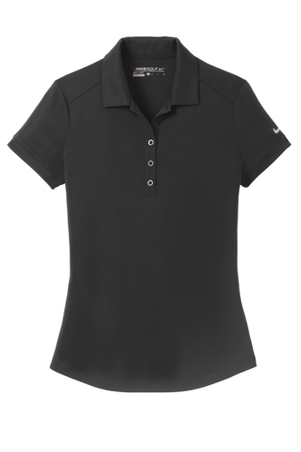

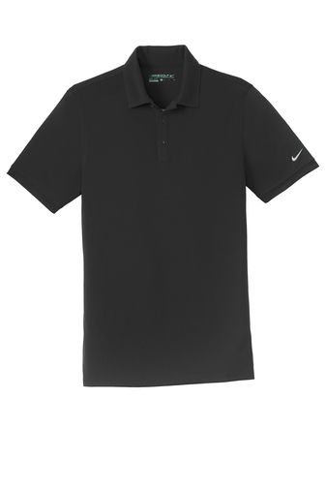

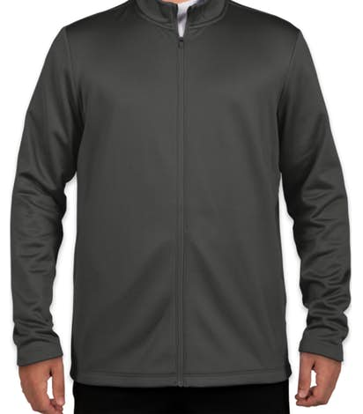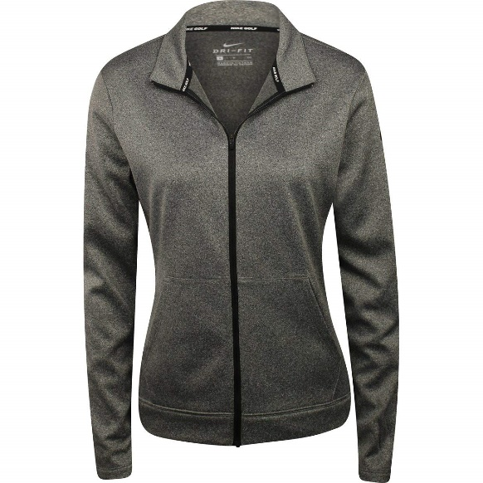

Iconic Nike Therma-Fit Performance Jacket

w/ embroidery